#### Group by User

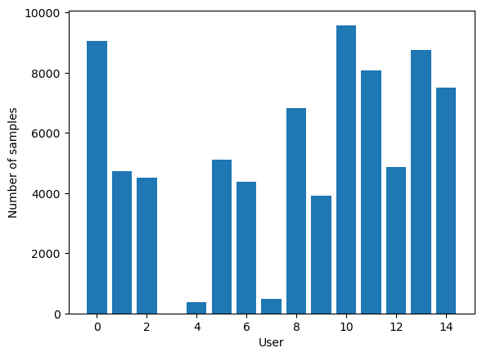

It appears that we have an imbalanced dataset. The number of instances in each class varies, with some classes having significantly more instances than others. Imbalanced datasets can pose challenges for machine learning algorithms, particularly when the minority class is underrepresented.

In our dataset, classes 3, 4 and 7 have relatively fewer instances compared to the others. This class imbalance can impact the model's ability to accurately learn patterns and make predictions, as the model may be biased towards the majority class.

Since we have a class imbalance where only a few classes have less than 500 samples, and the majority of classes have samples in the range of 4000 to 9000. When implementing the algorithm we will take care to evaluate model performance: Start by training and evaluating our model on the imbalanced dataset. Assess the performance metrics such as accuracy, precision, recall, and F1-score for each class.

User 0:

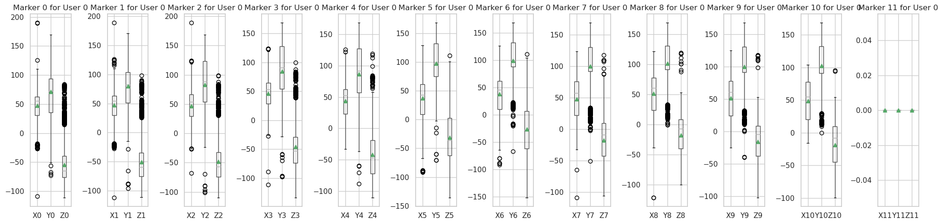

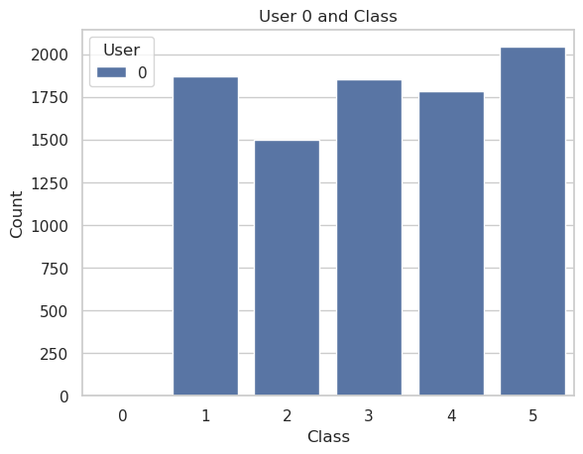

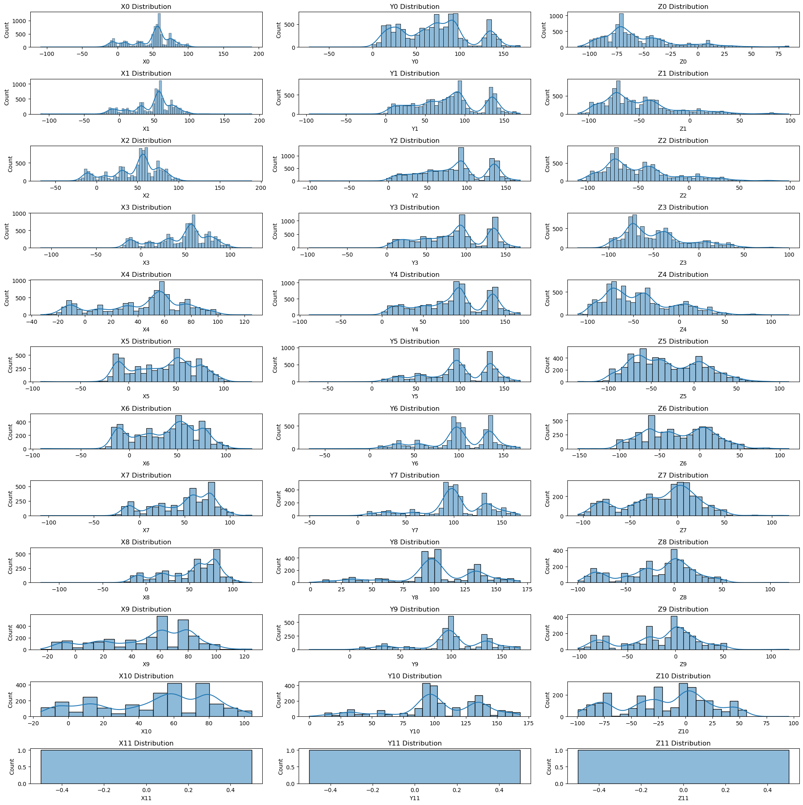

User 1:

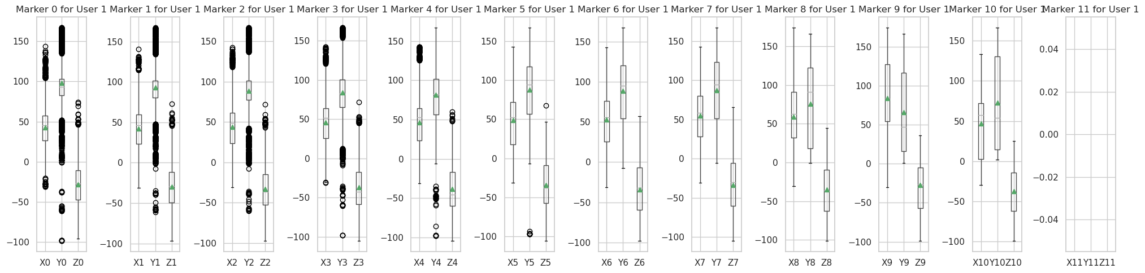

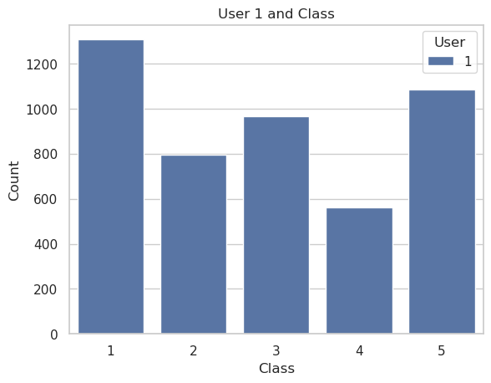

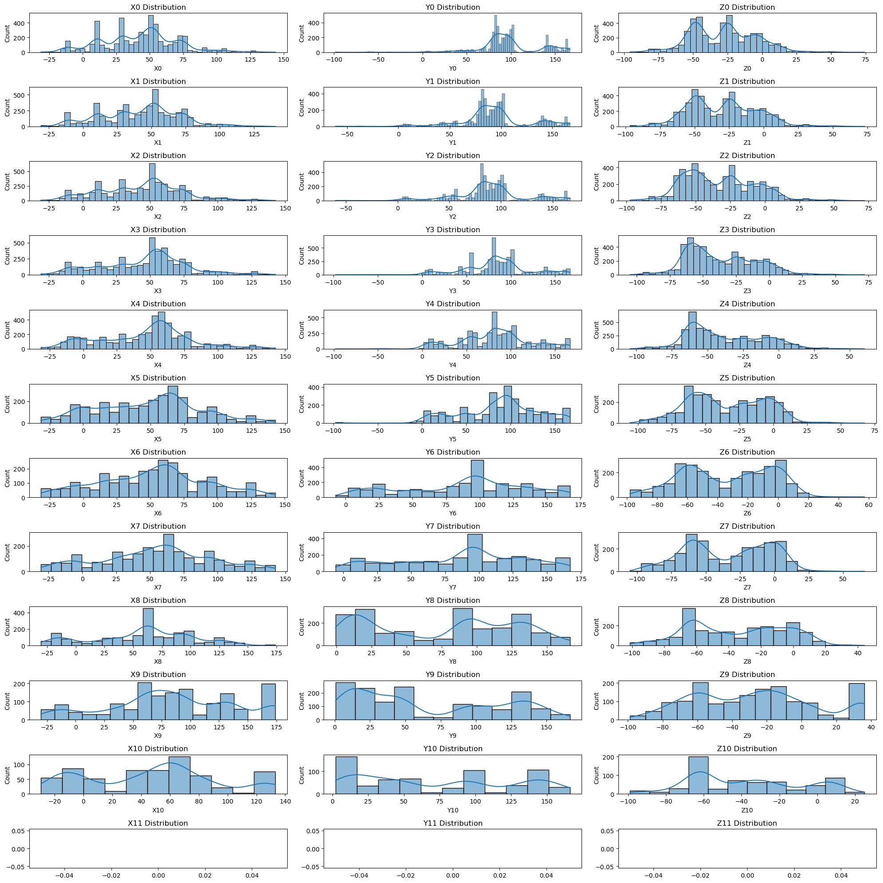

User 2:

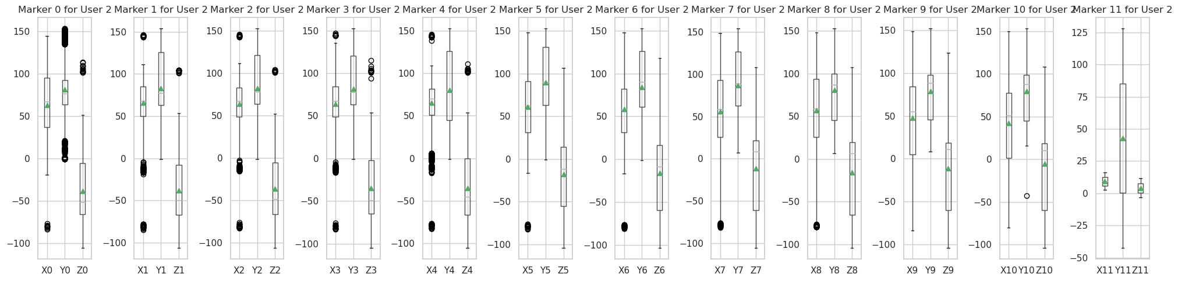

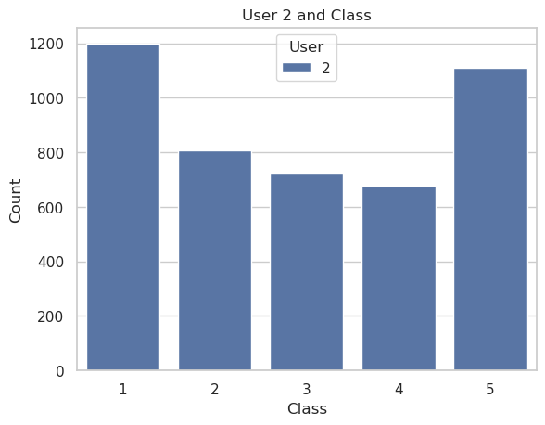

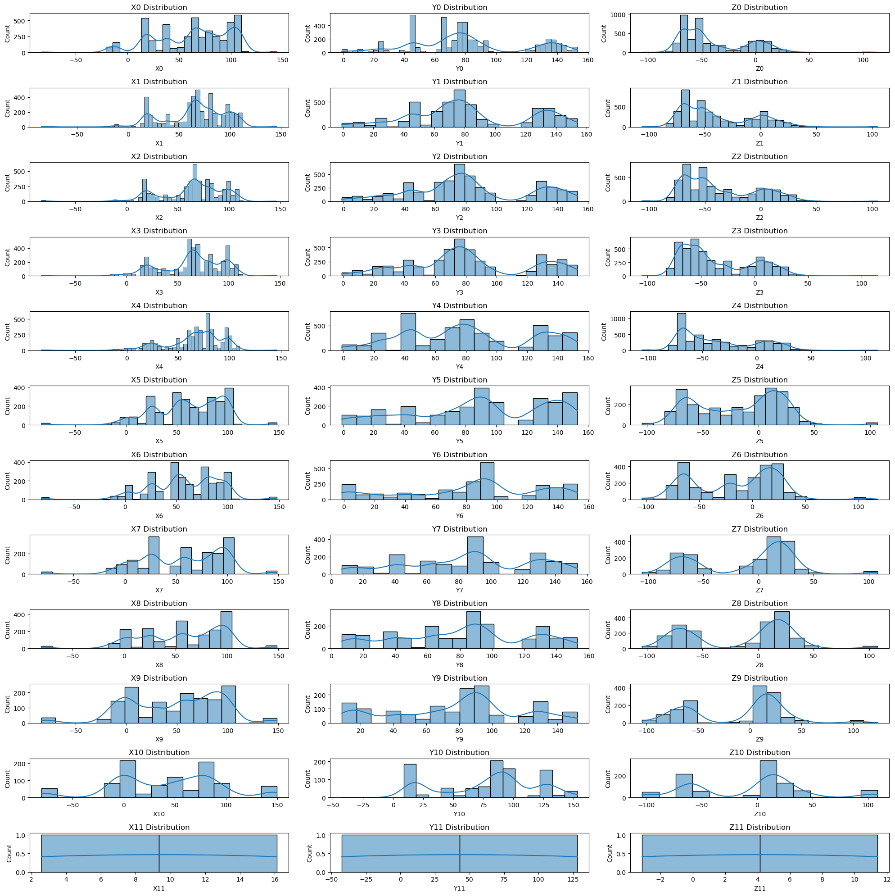

User 3: We don’t have User 3

User 4:

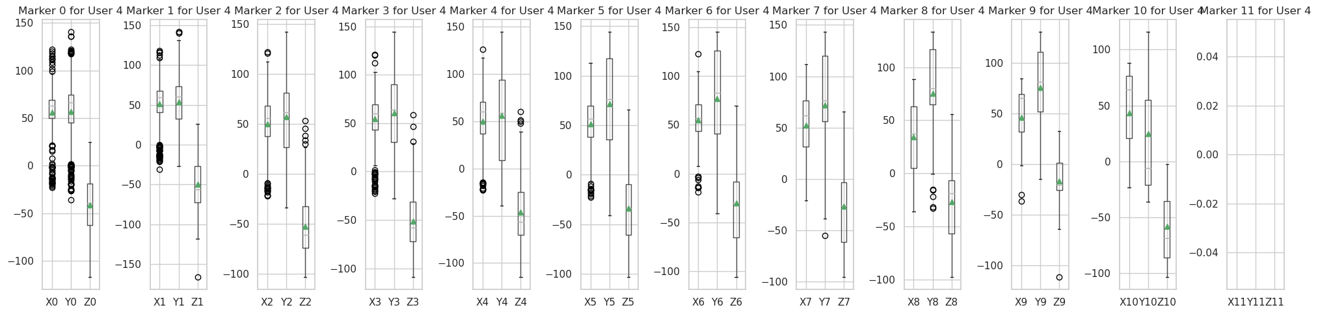

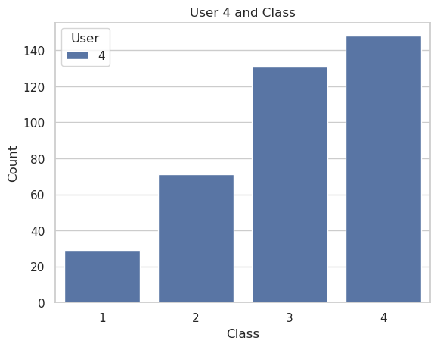

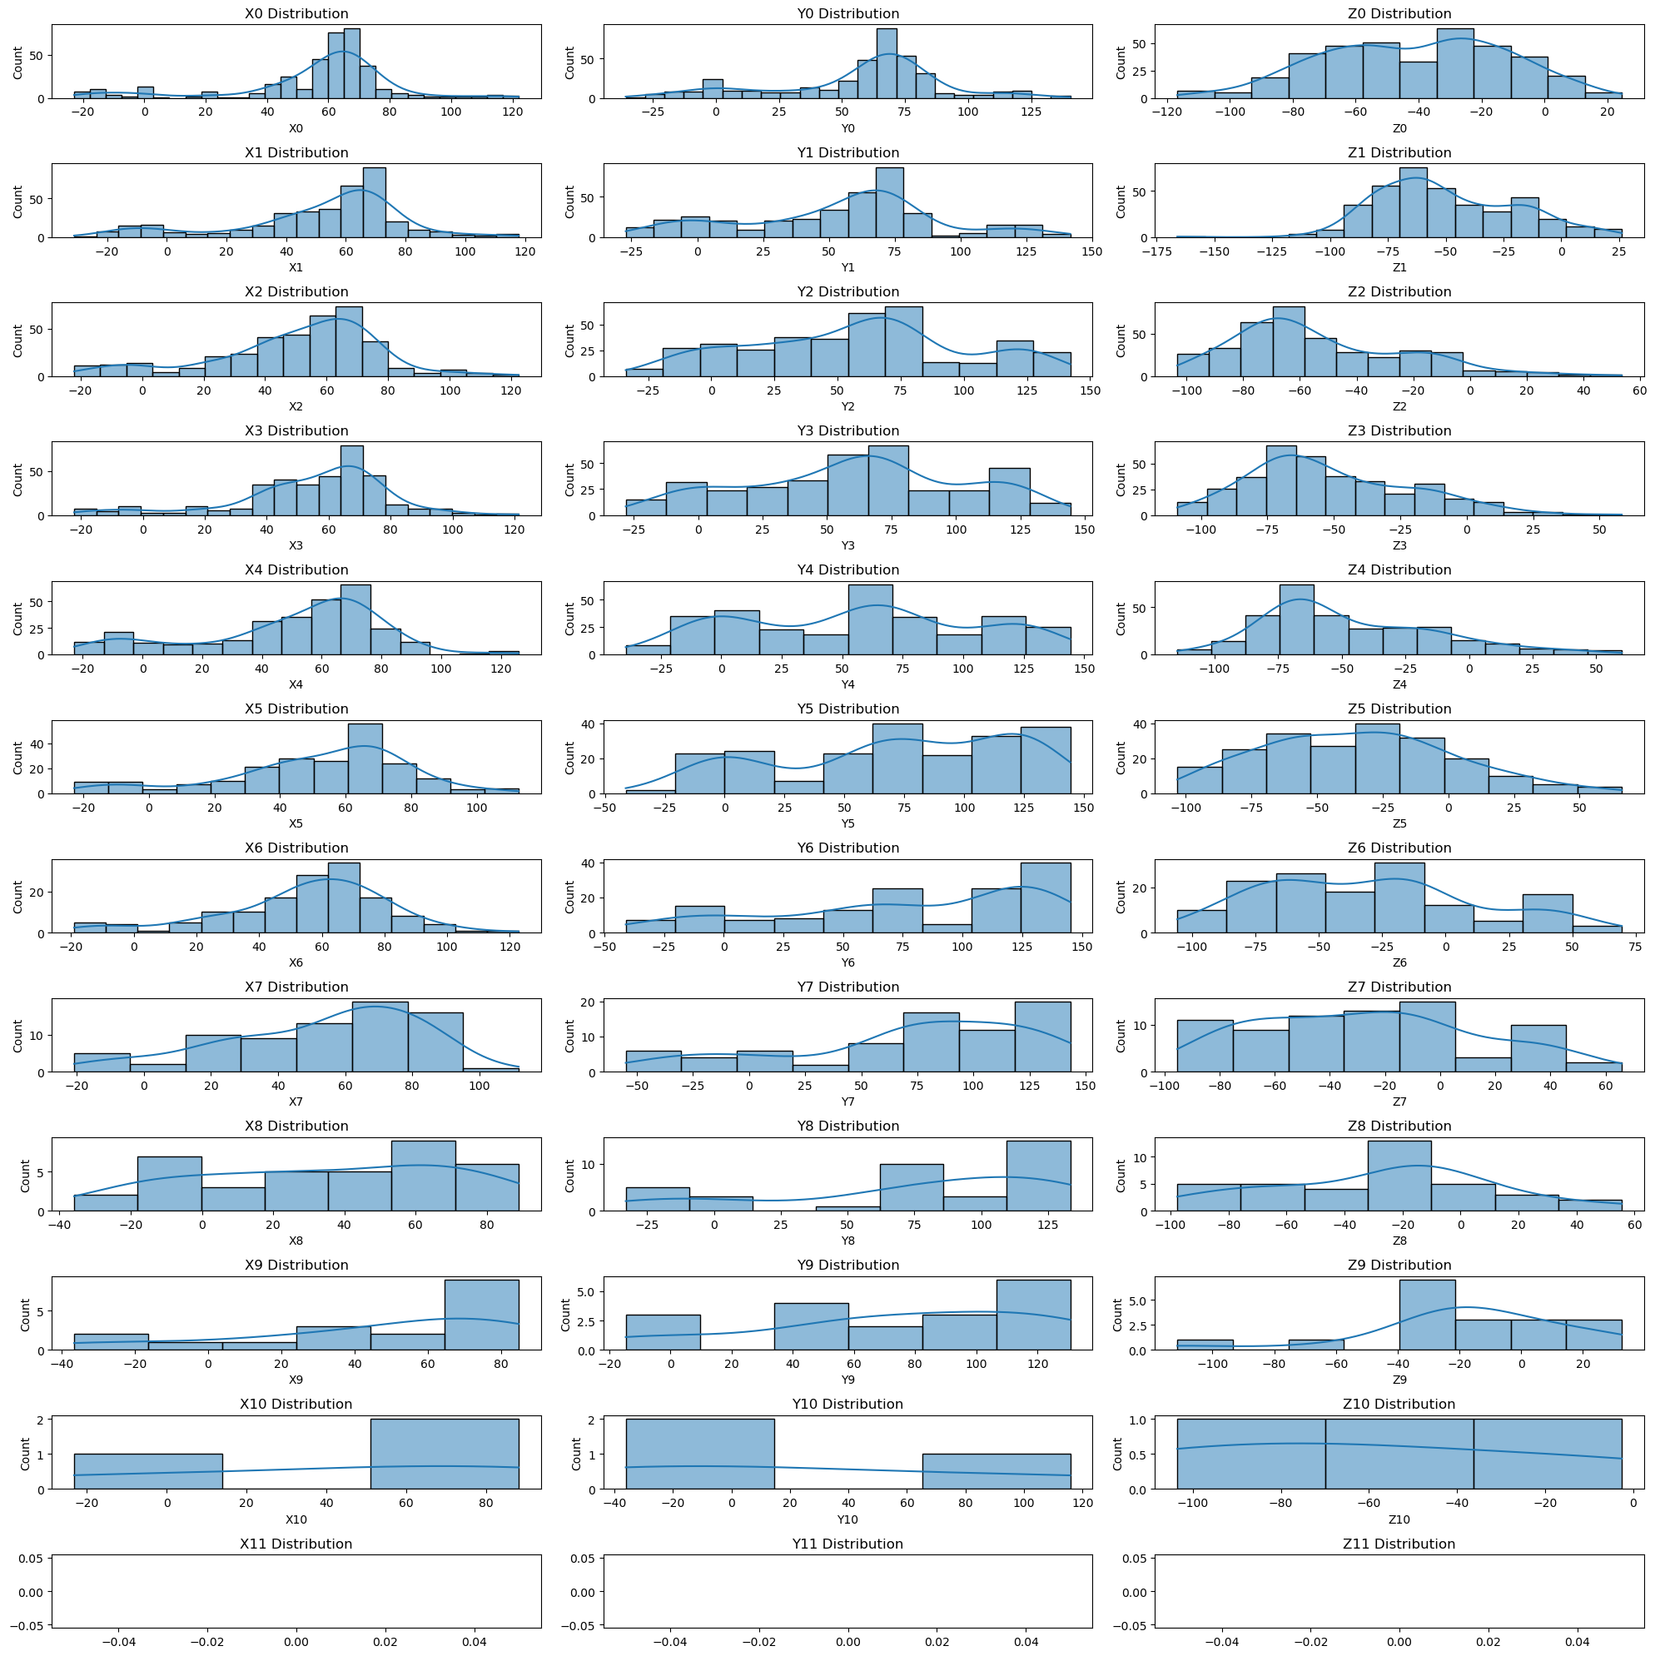

User 5:

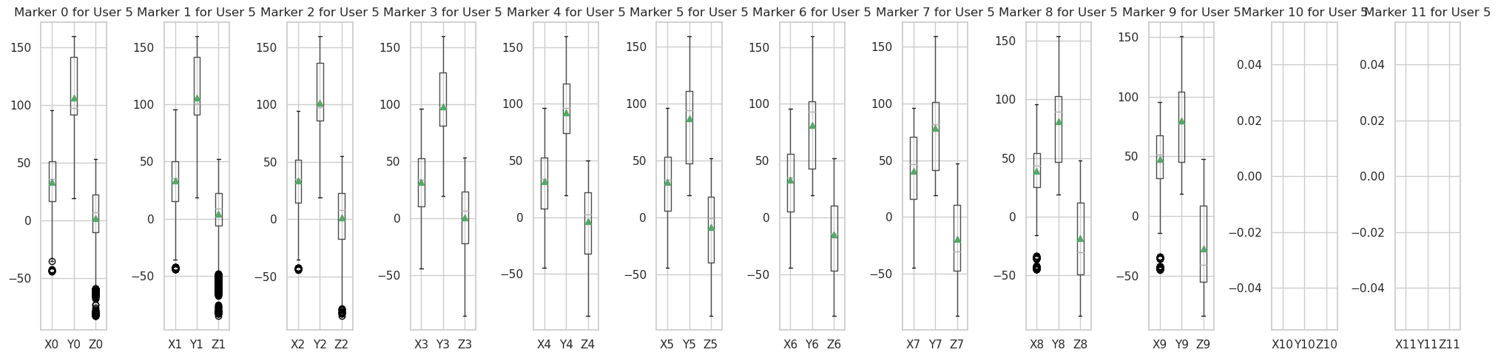

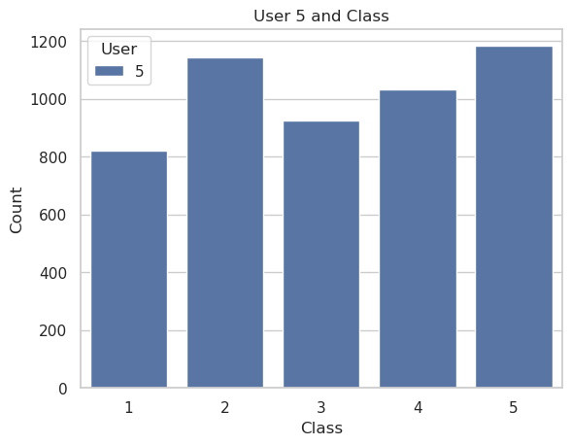

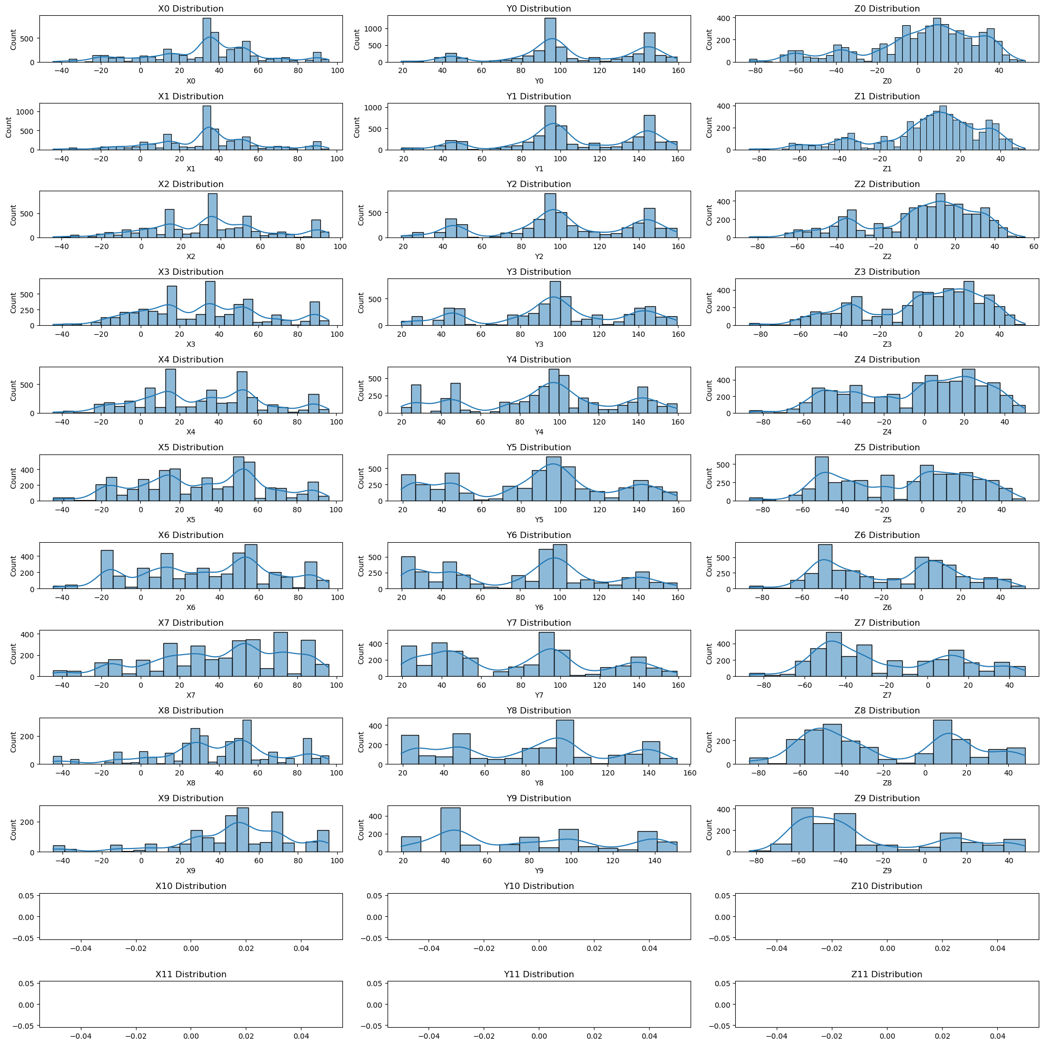

User 6:

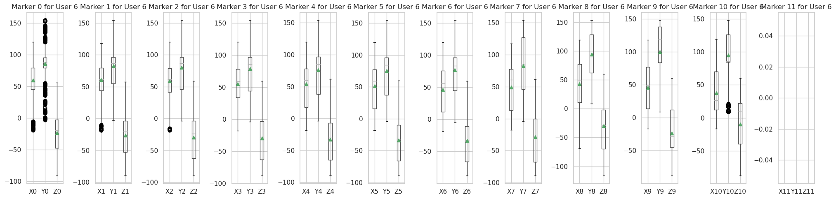

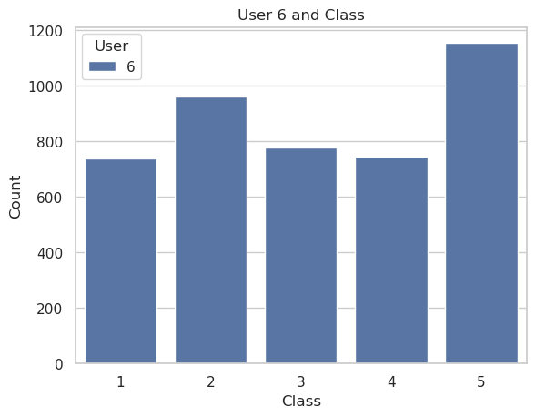

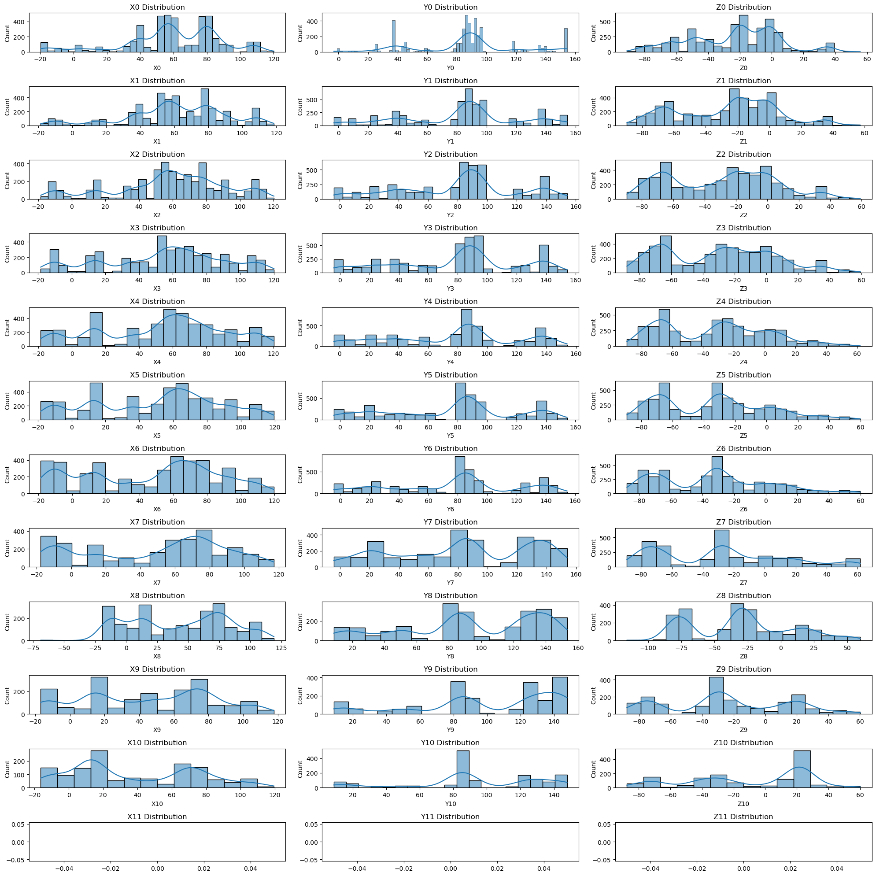

User 7:

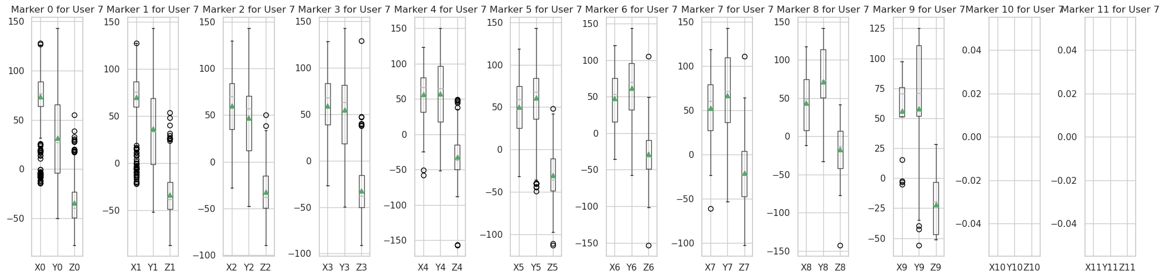

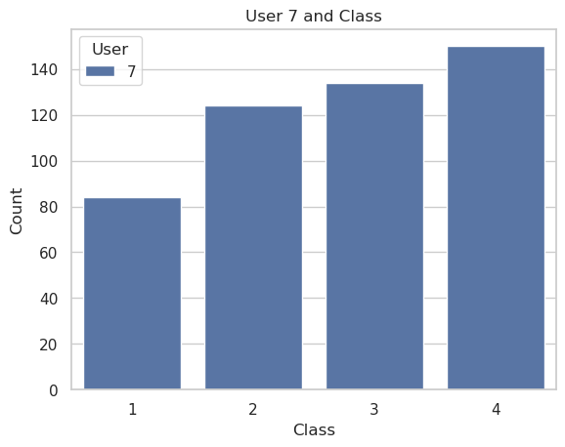

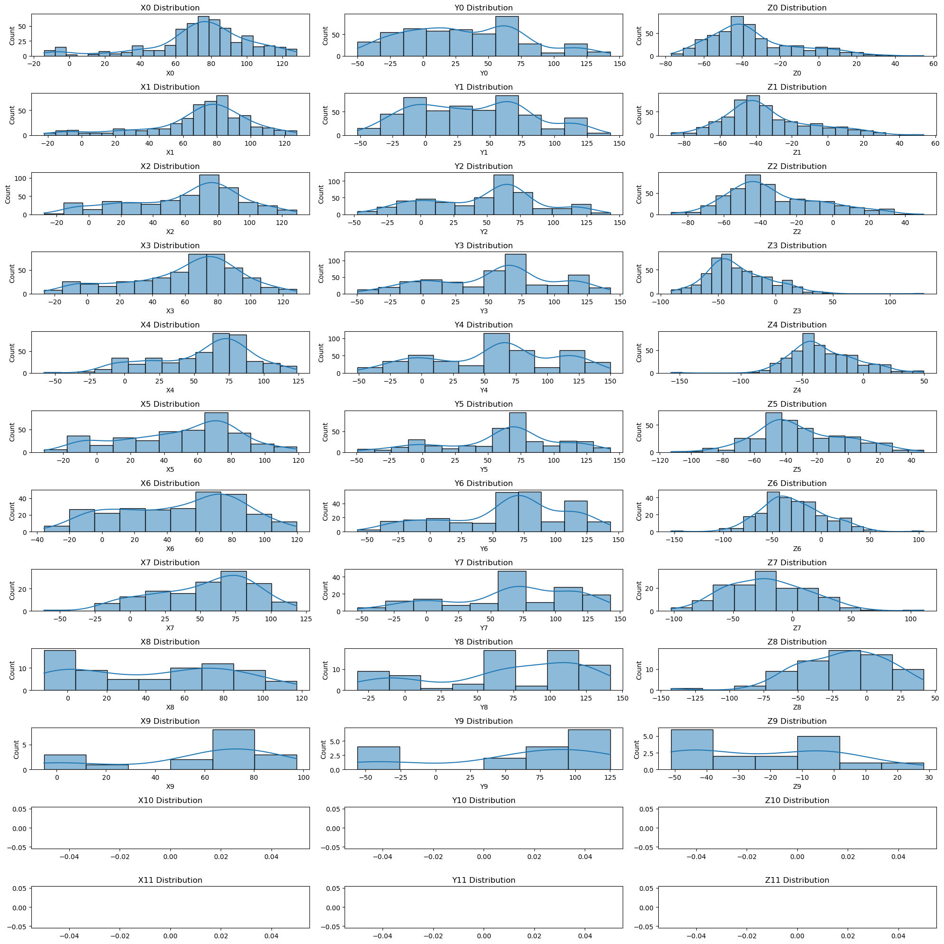

User 8:

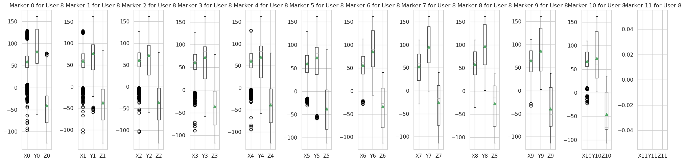

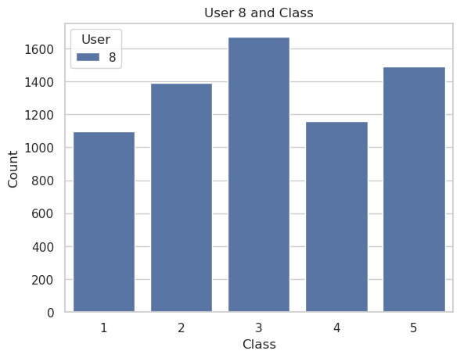

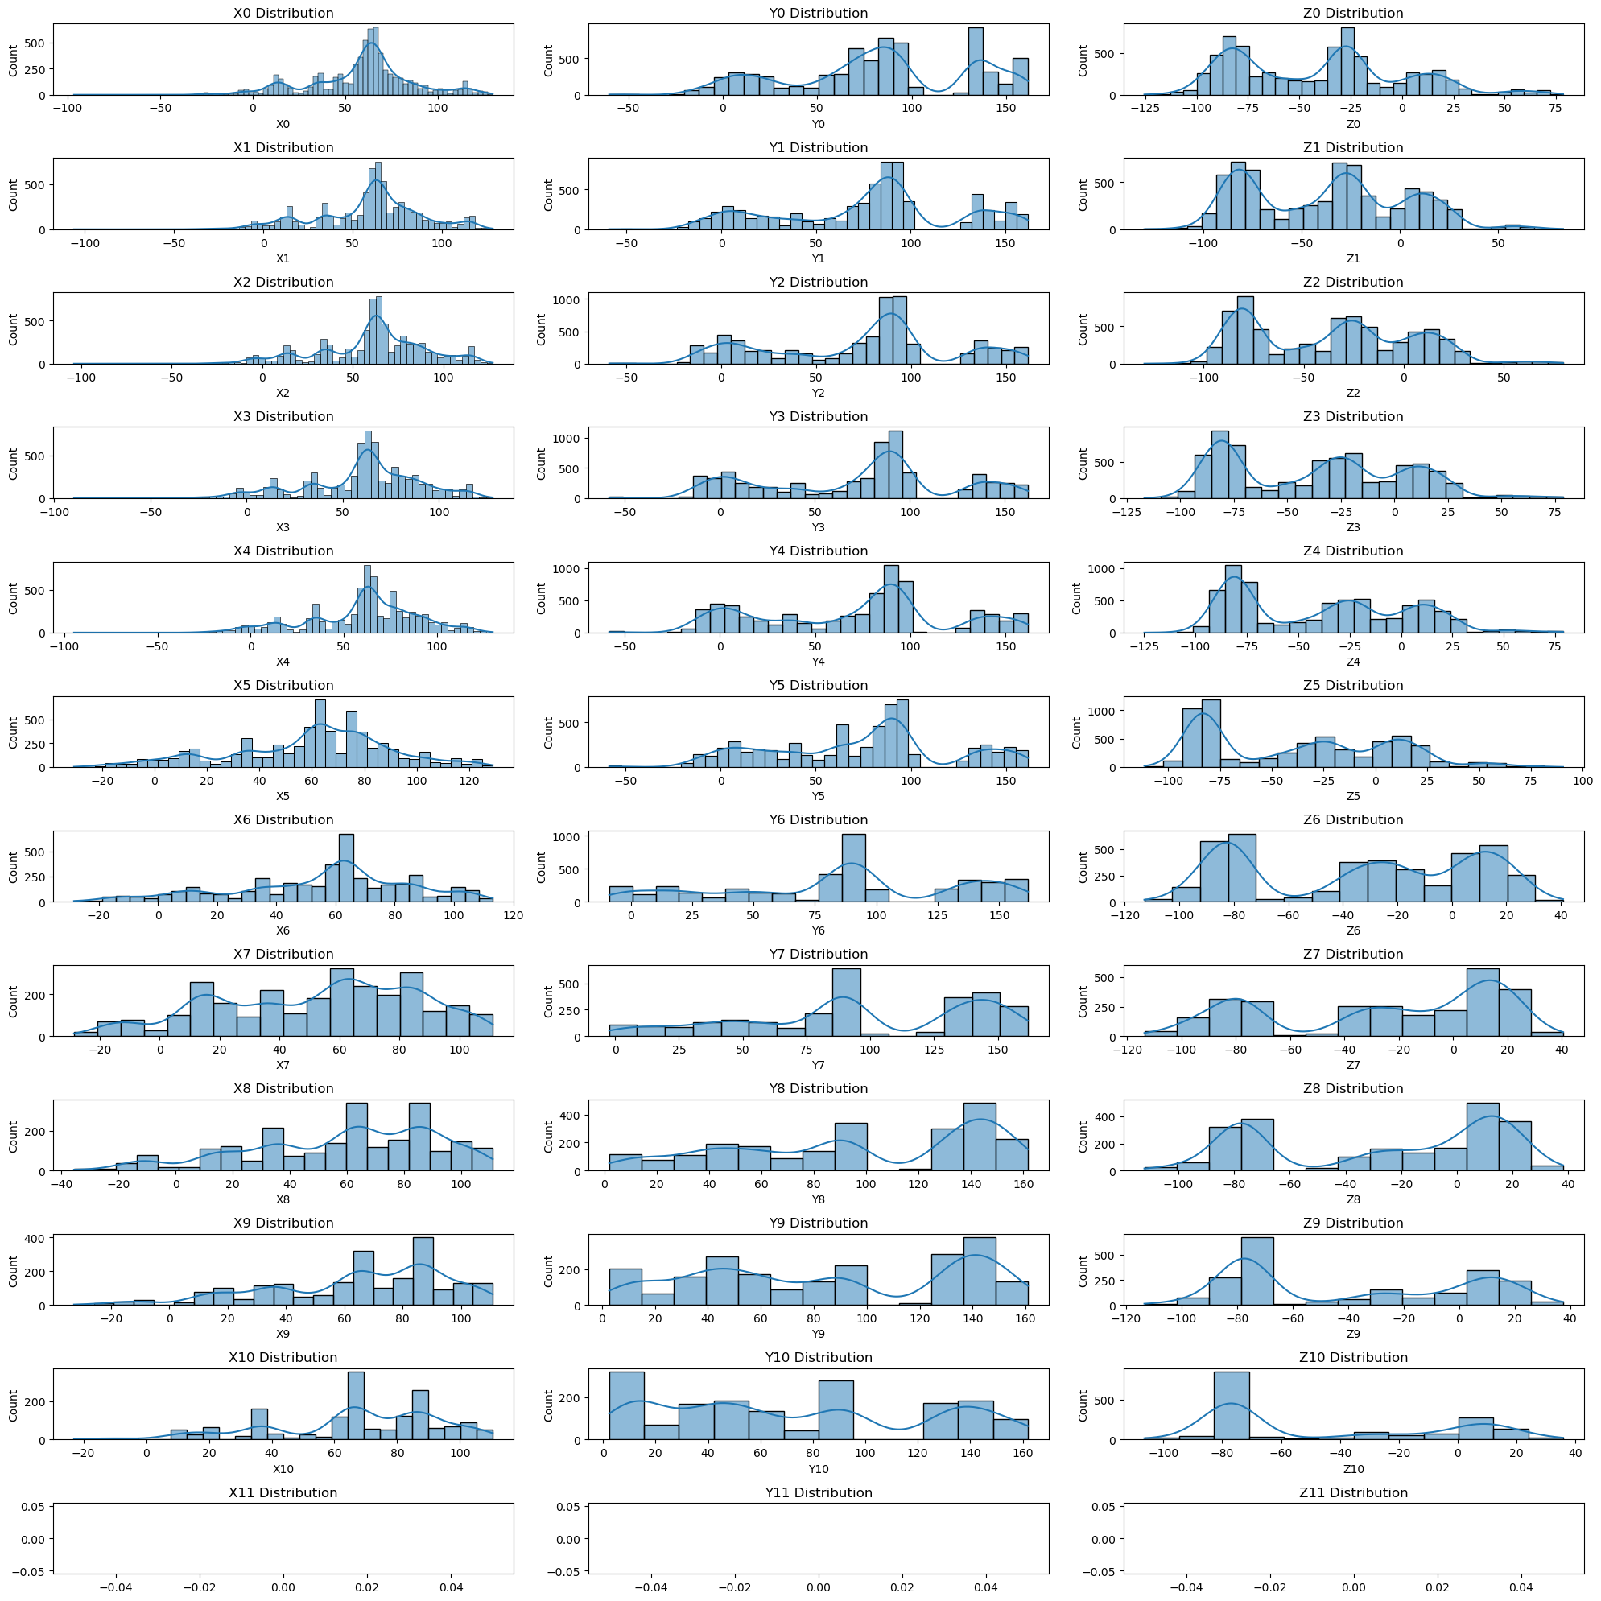

User 9:

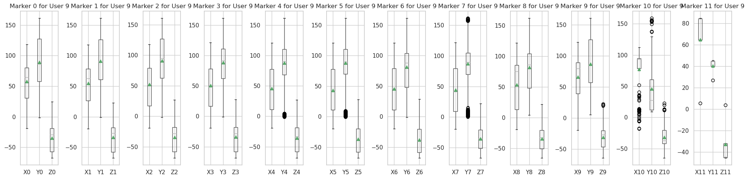

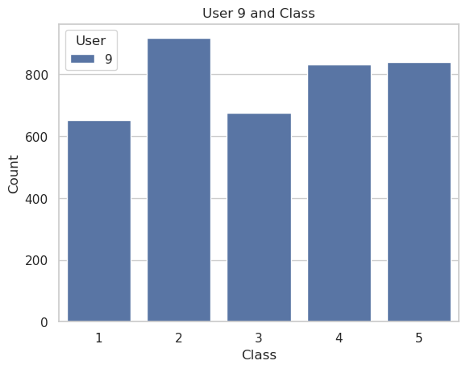

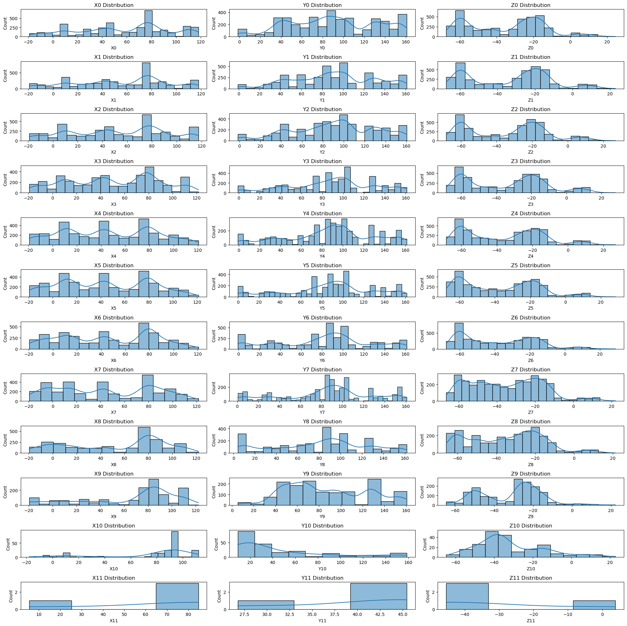

User 10:

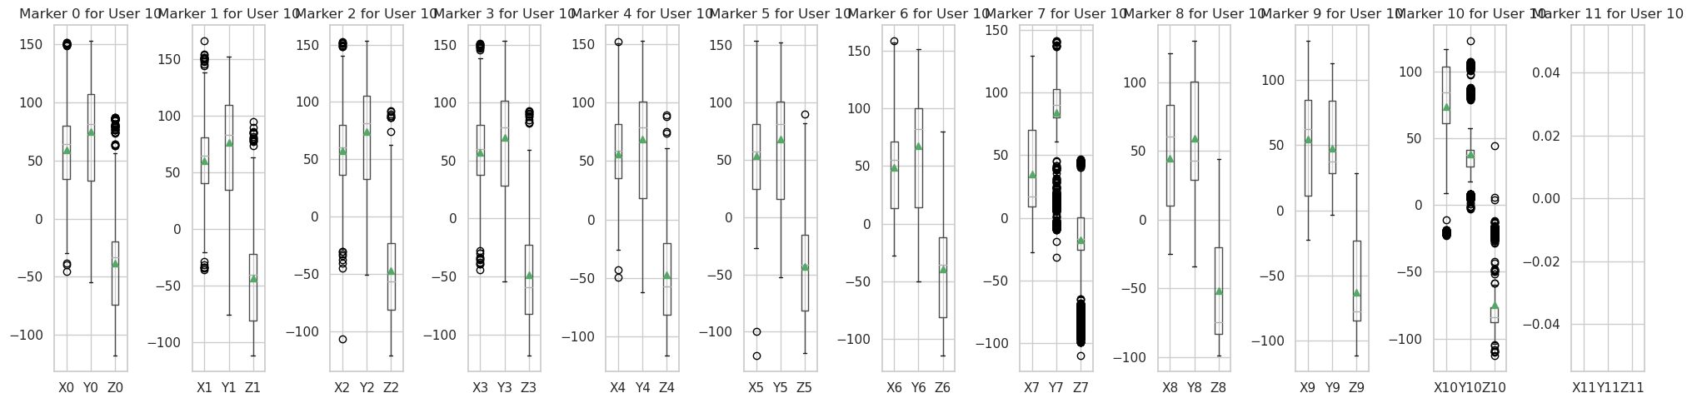

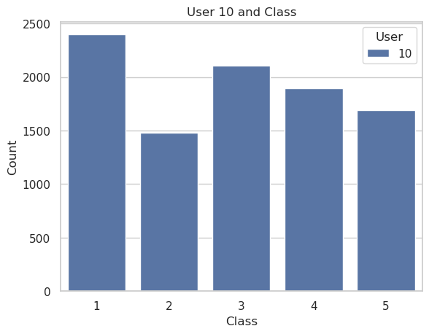

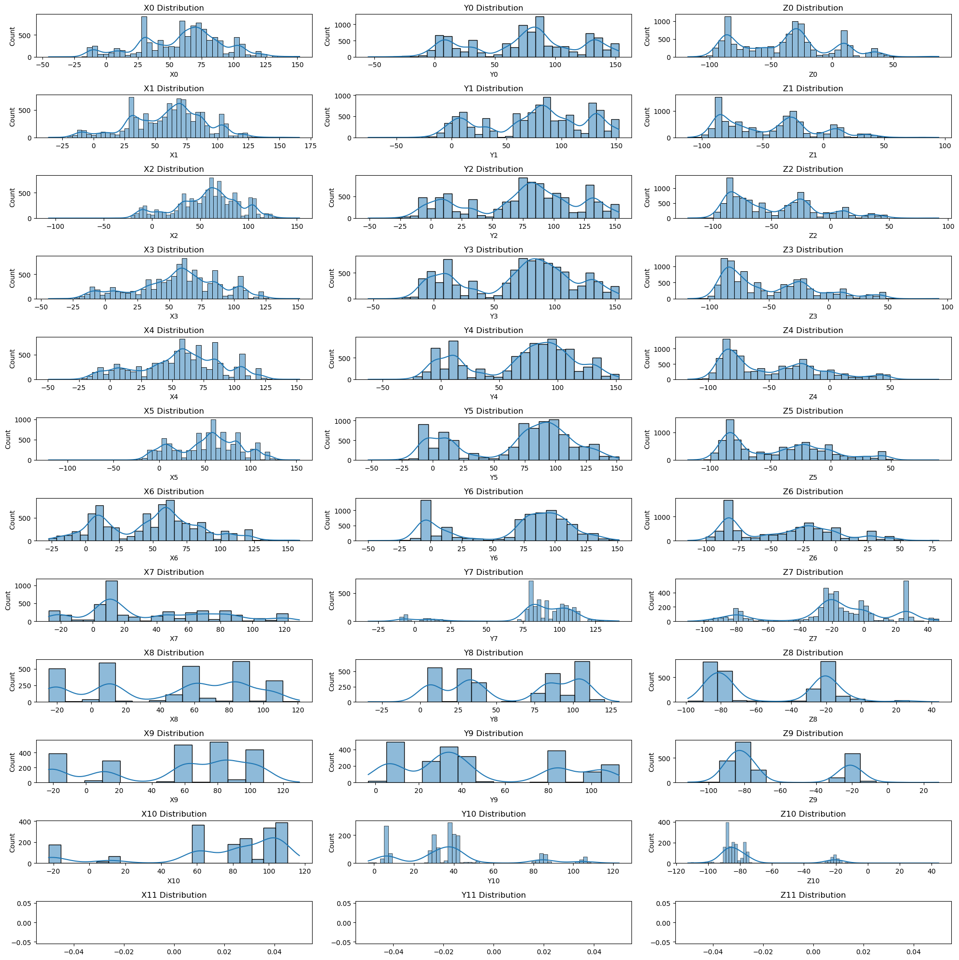

User 11:

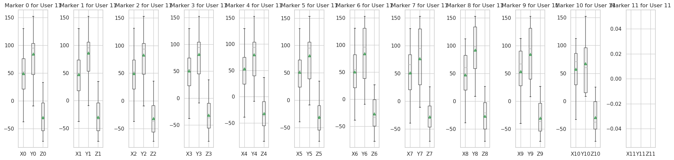

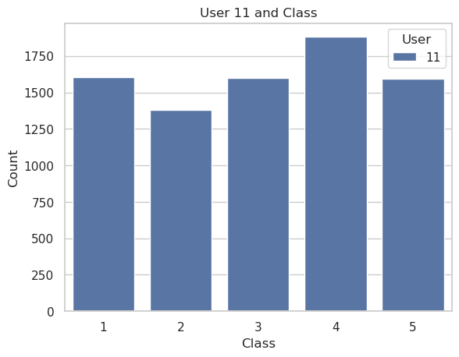

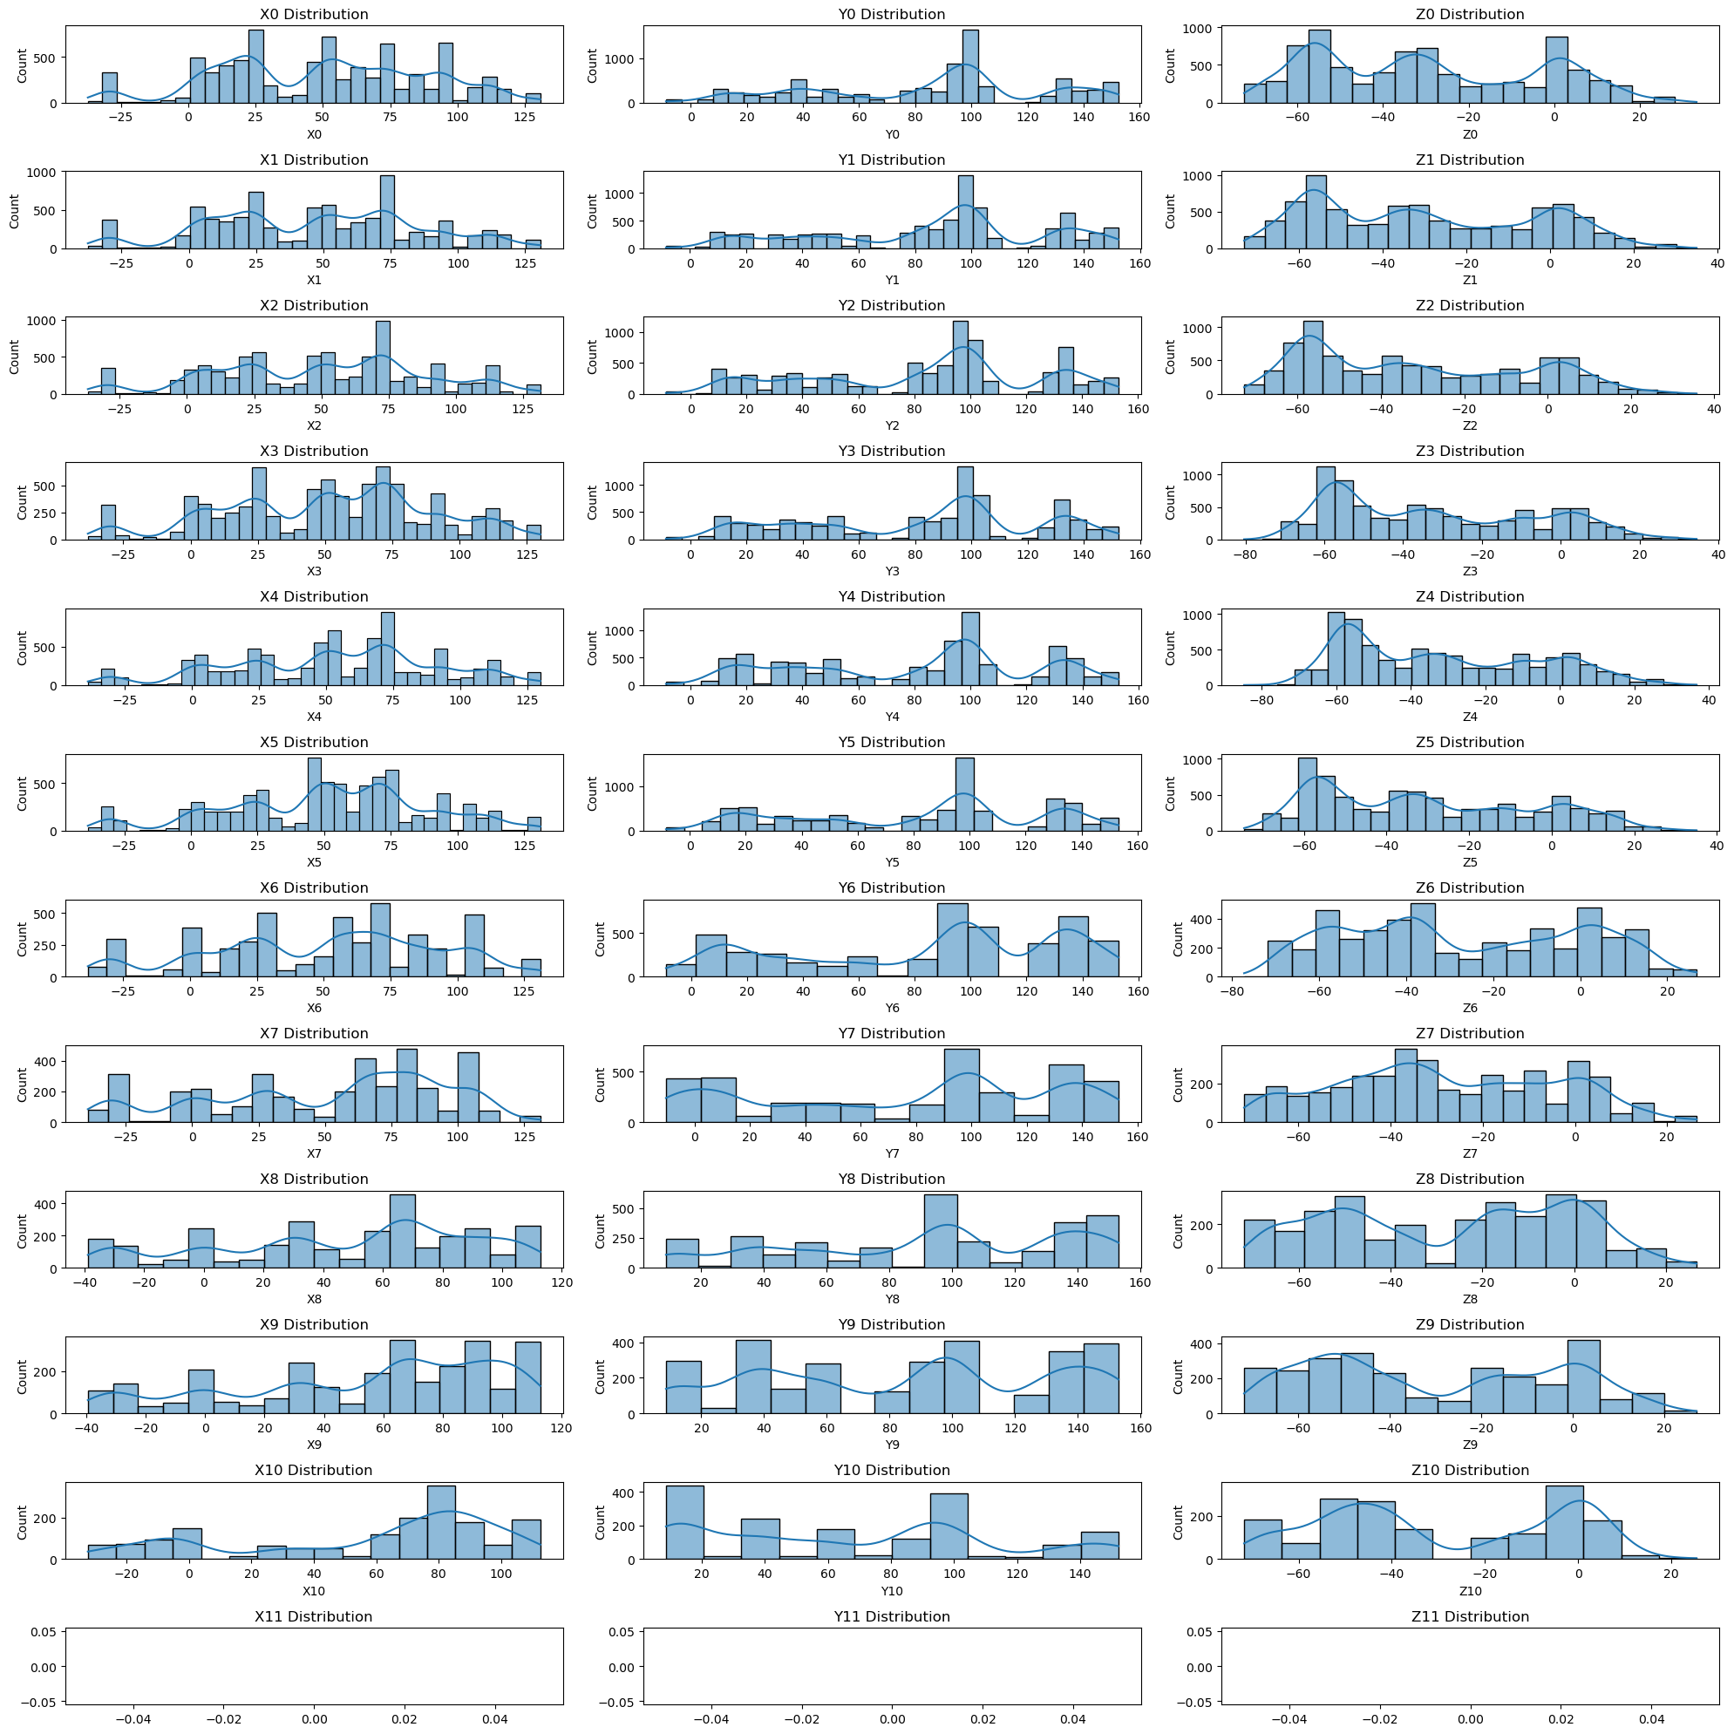

User 12:

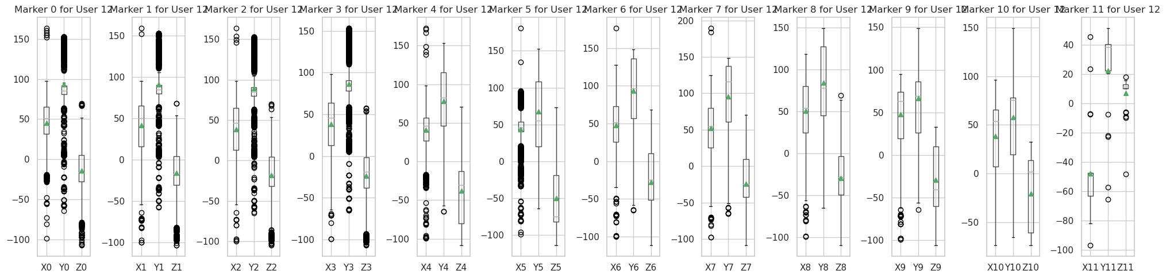

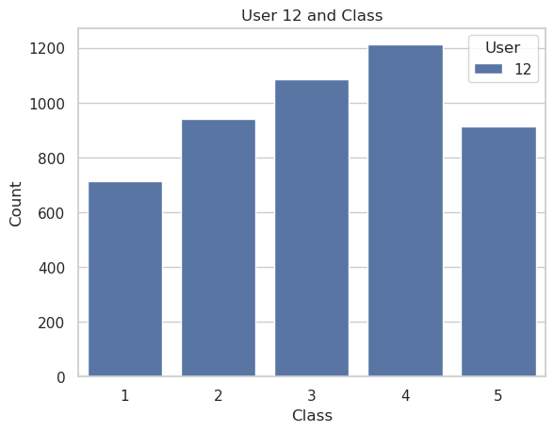

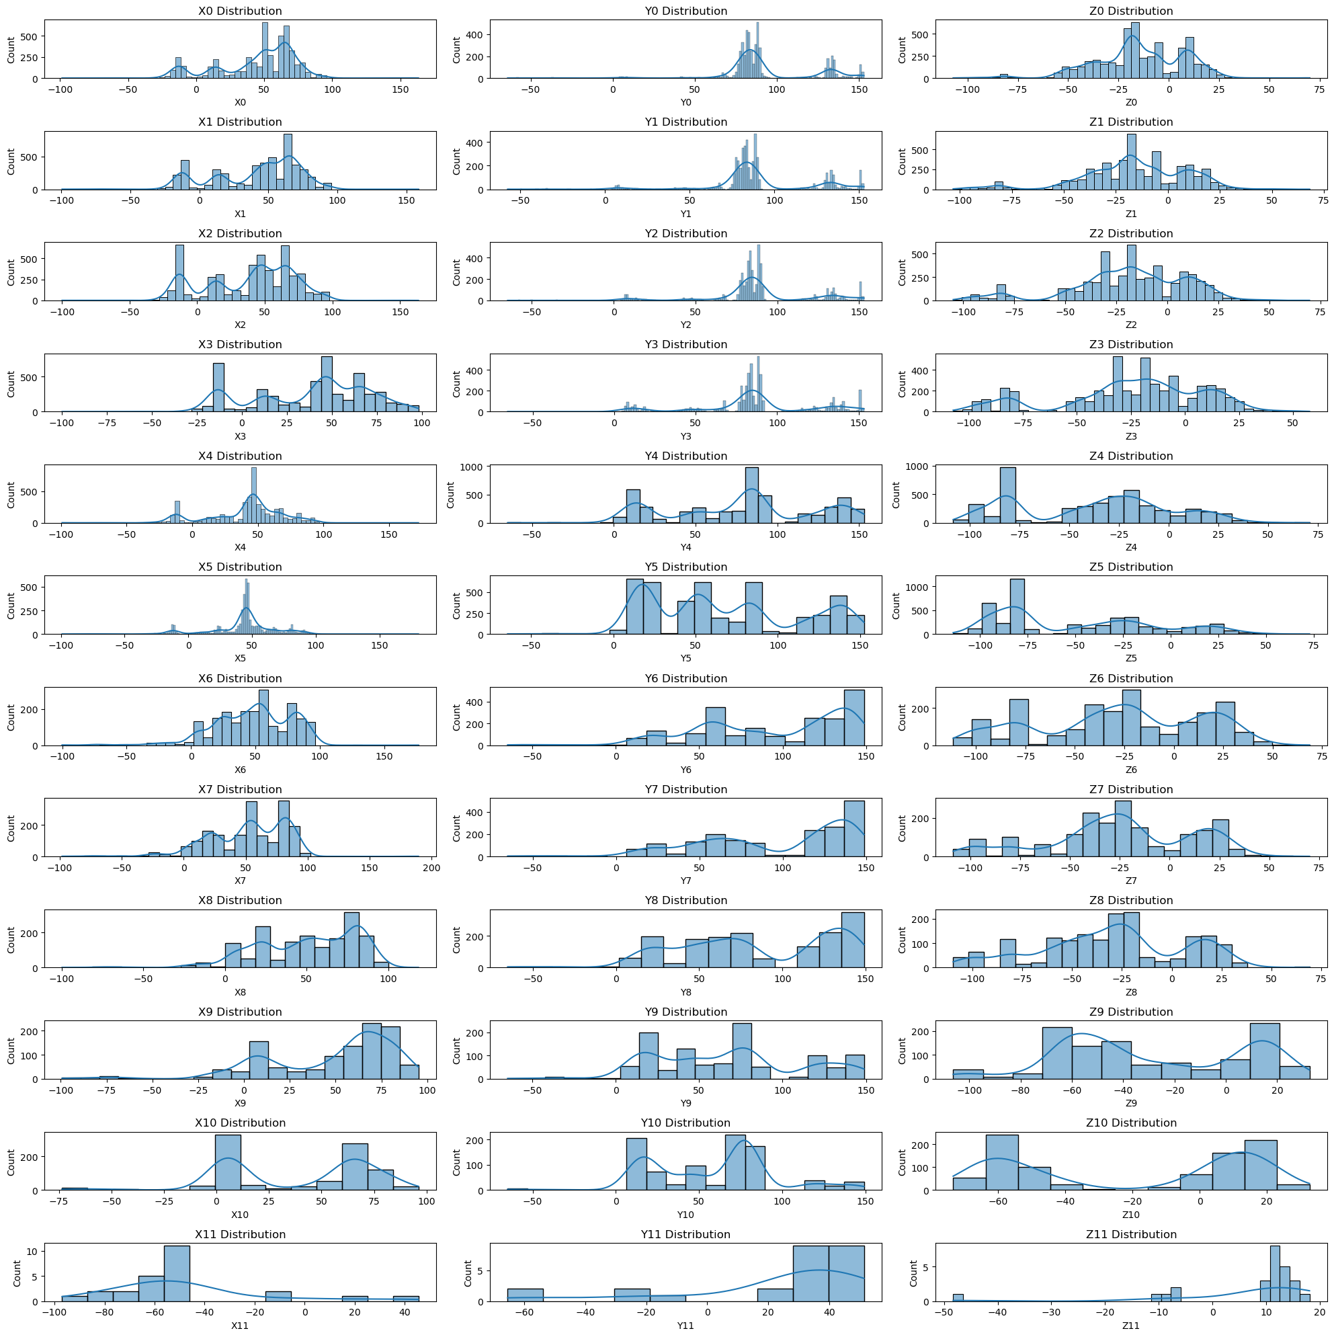

User 13:

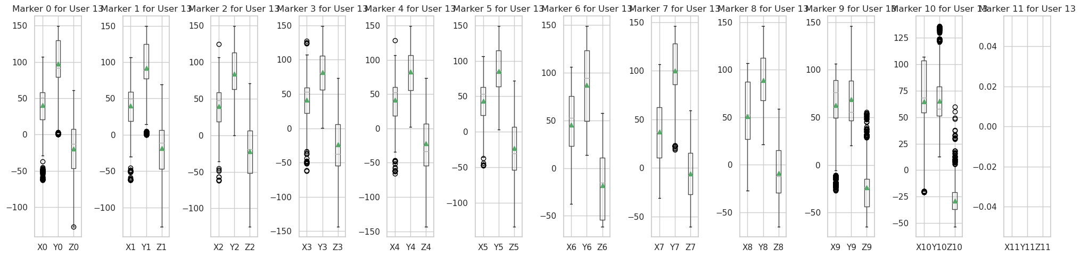

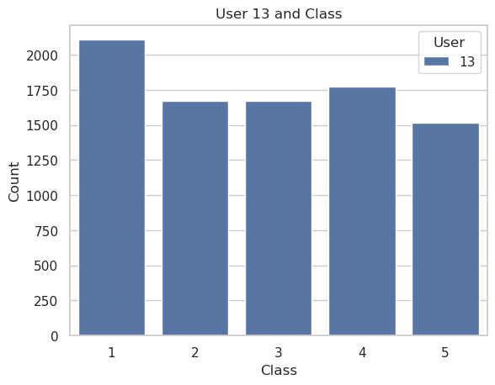

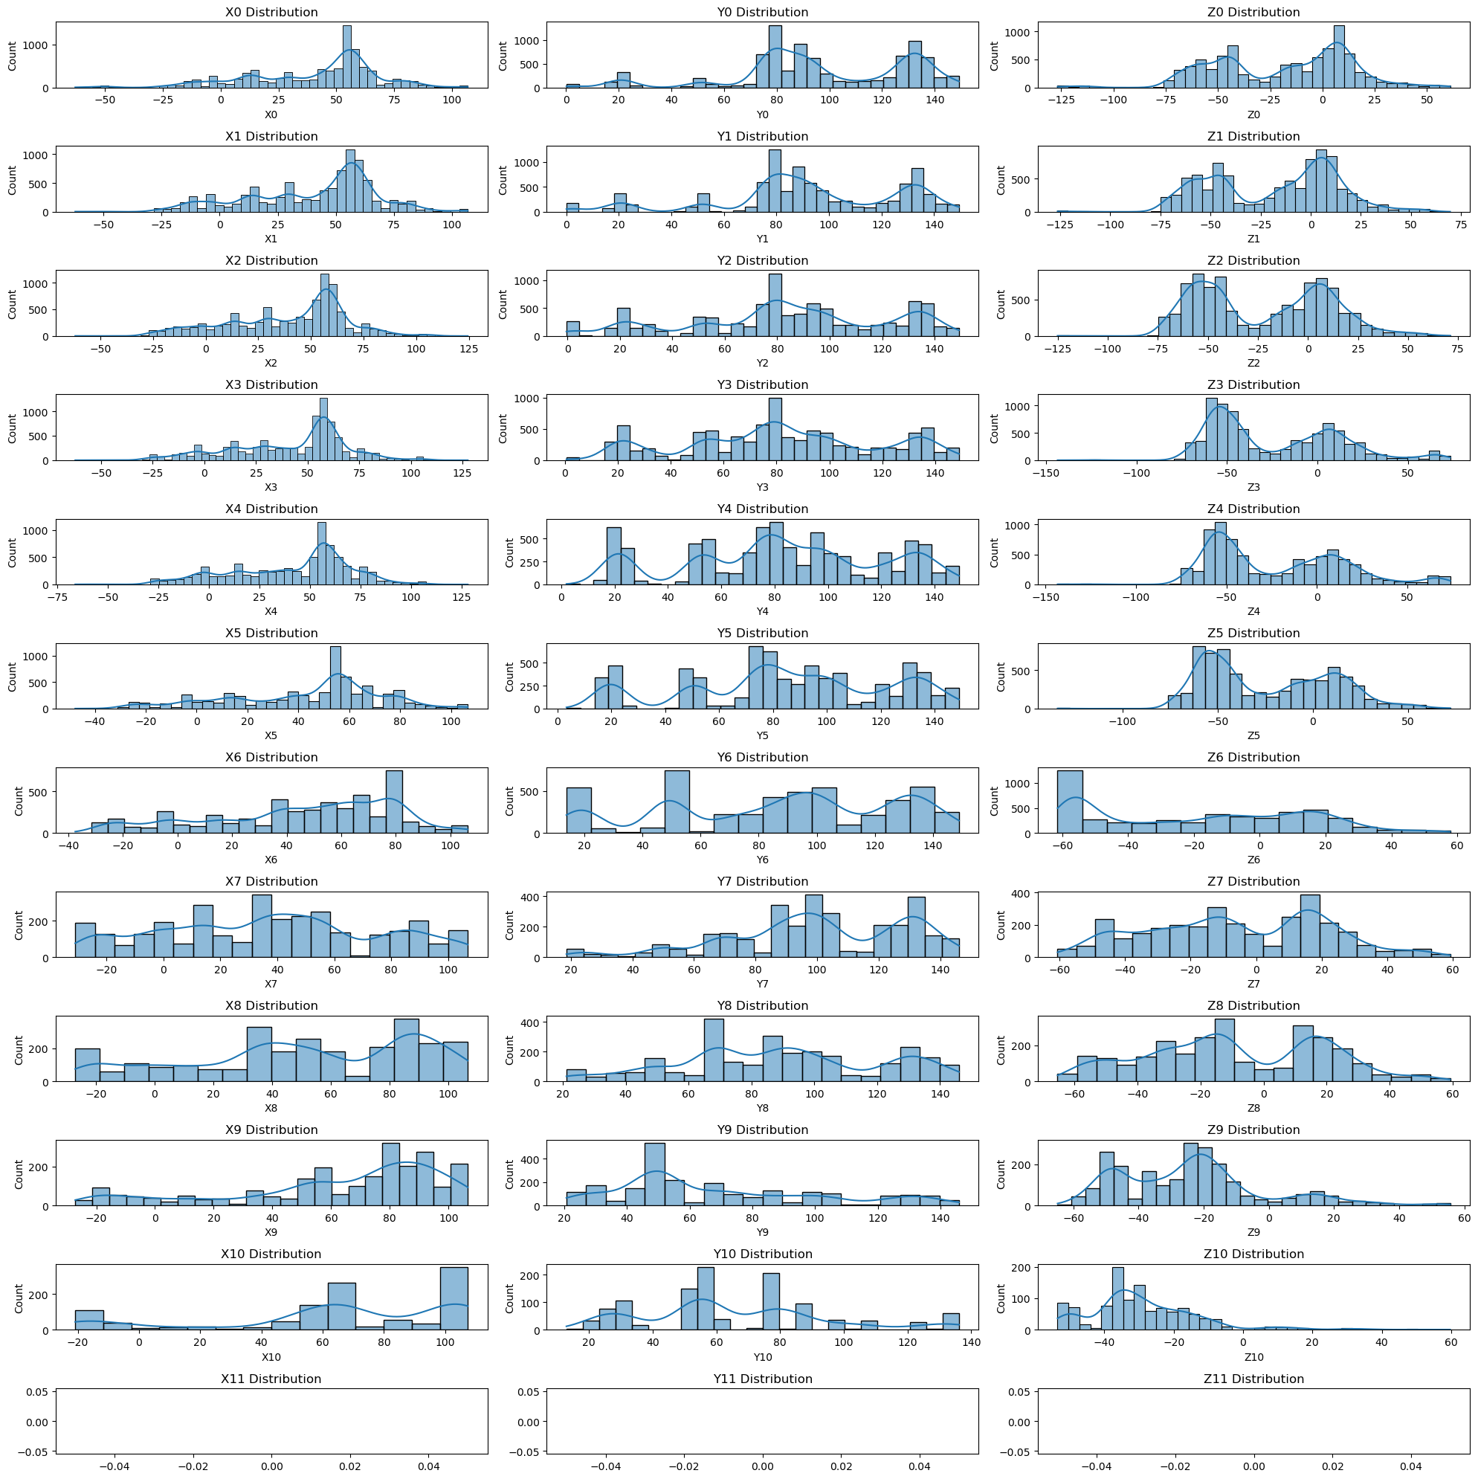

User 14: 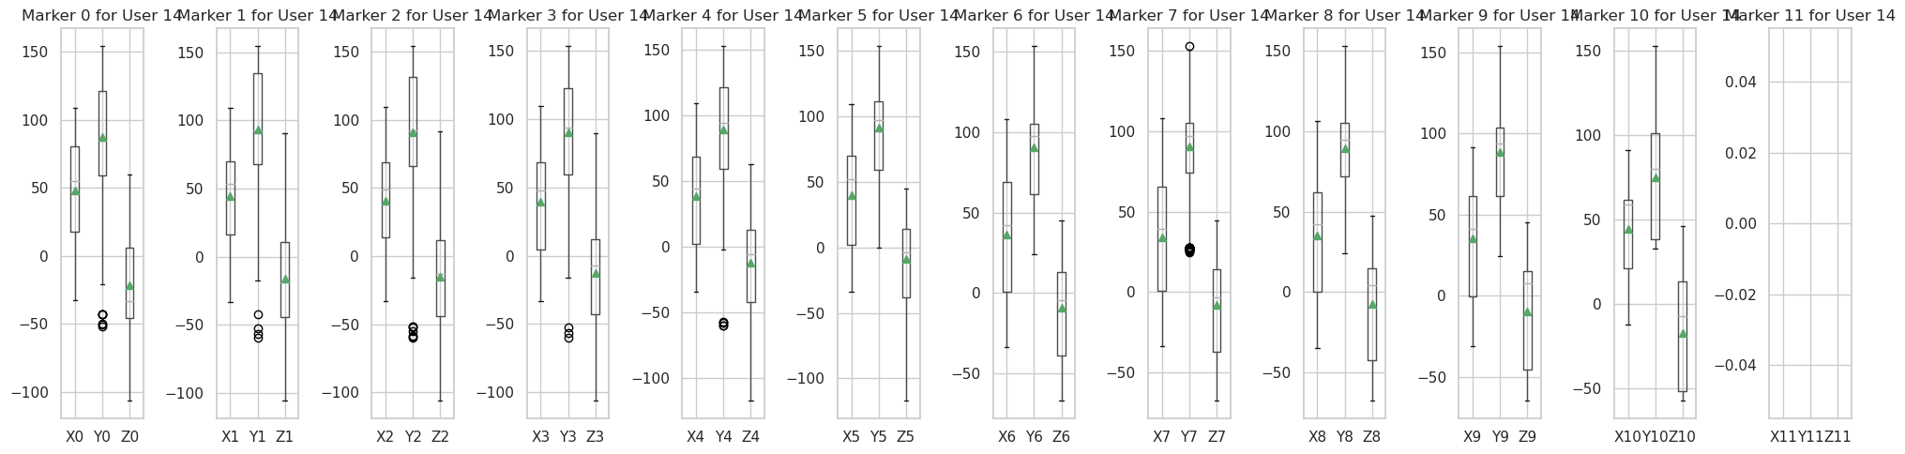

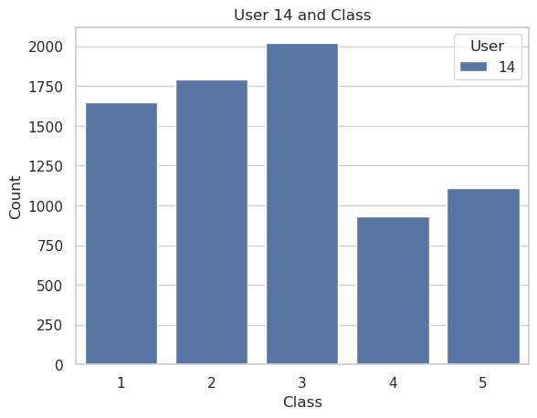

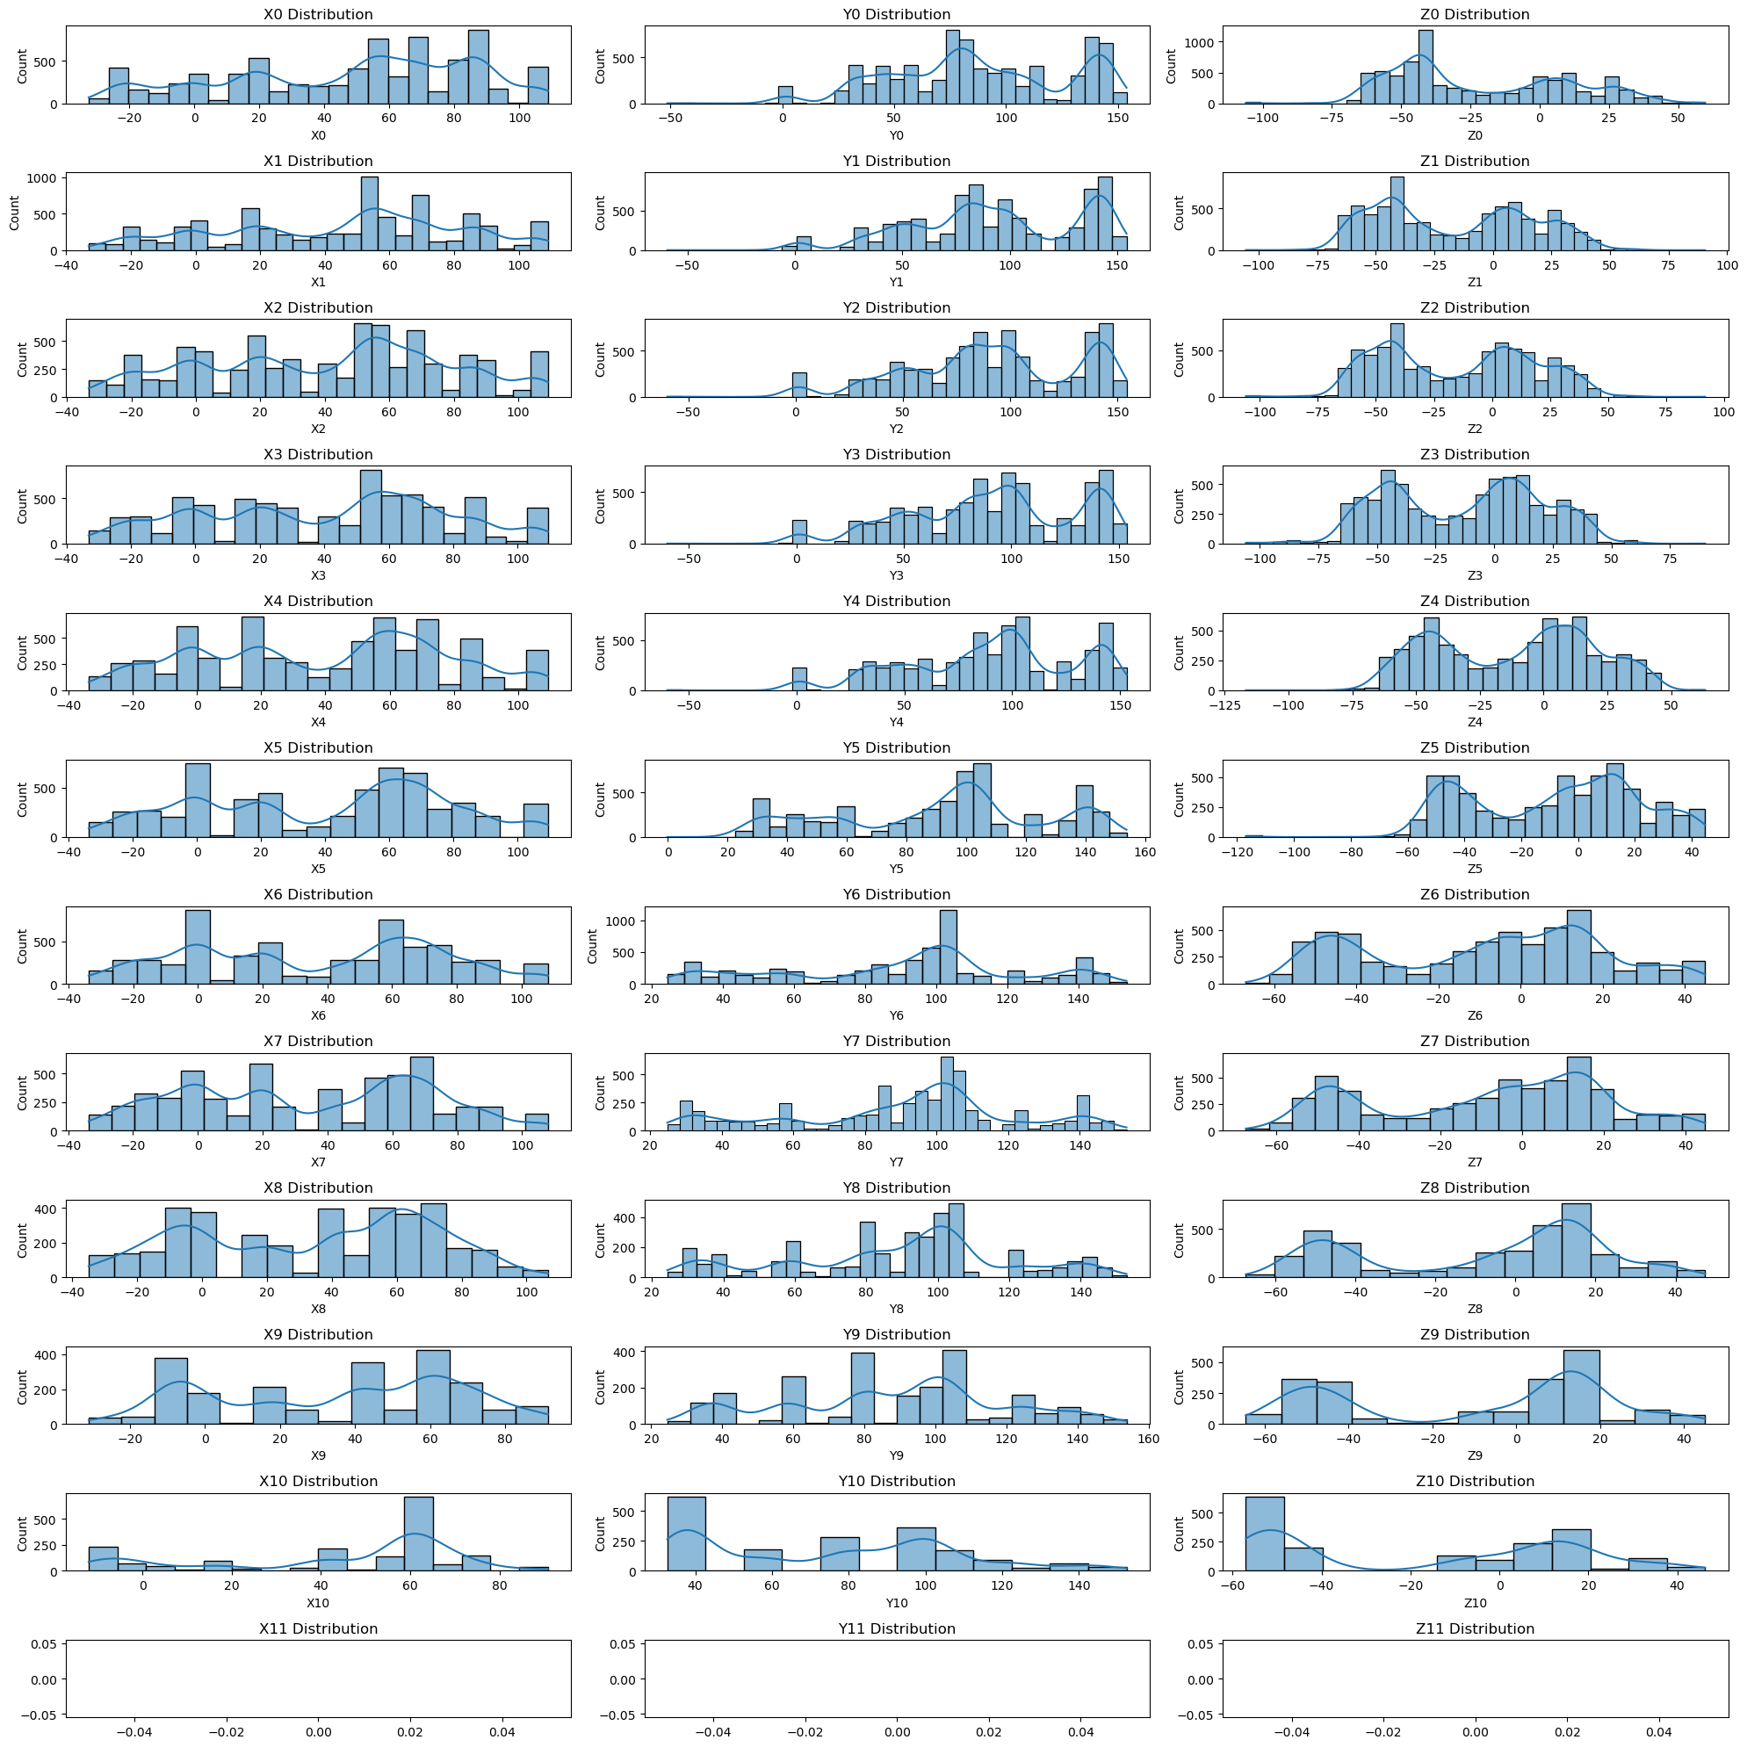

As we saw in the previous section, the shape of the histograms for the features within the same set Xi, Yi, Zi is very similar, or even more, they have the same shape. However, as we saw before, as the marker number increases, the histograms of the markers become less similar to those at the beginning. If we pay attention, this difference between the markers becomes very prominent for markers 6 and 7. And if we recall from the missing data analysis, marker 6 has a 33% missing data rate, and marker 7 has a 50% missing data rate. Therefore, this change in the histogram distributions is mainly related to the percentage of missing data.

This difference in the shape of the histograms especially impacts the outliers. Generally, we observe zones in the histograms where the number of samples is concentrated, and zones where the concentration is very low. This difference is clearly visible in markers with smaller numbers (where there is not much missing data). However, for example, in marker 7, this difference in concentrations is hardly noticeable. A suitable example for this situation is when you are drunk (with a lot of missing data) and throwing darts at a target. It is obvious that you will miss more when you are drunk compared to when you are sober.

Another important aspect to mention is that none of the histograms have a known distribution. There are some that resemble the normal distribution, for example, some histograms from the Xi set, but we see that none of them exhibit symmetry. Therefore, it becomes difficult to define a specific value to consider as outliers. In the end, we have decided not to discard these values that deviate from the mean because they may provide useful information, and we do not know the underlying distribution of the features.

## **5.3 Decision Trees**

To begin with, since we do not have any data imbalance issues, we applied the default DecisionTreeClassifier from sklearn directly after preprocessing the data, without imposing any parameter constraints:

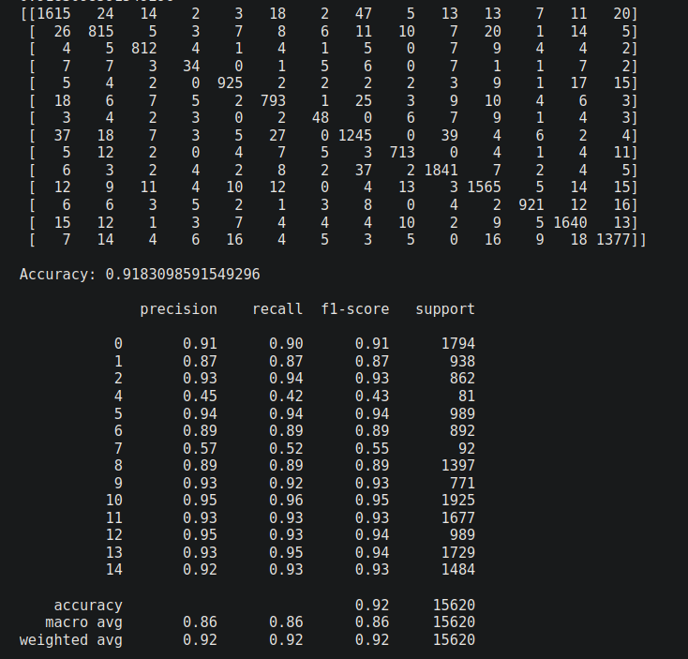

For our database and the prediction task at hand, we will prioritize accuracy as a more important metric since we are predicting postures, and values such as false positives and false negatives do not hold significant importance.

The accuracy of your classifier on the test data is approximately 0.91, which indicates that it is correctly predicting the postures for a significant portion of the samples.

The confusion matrix shows the number of samples that were classified into each posture category. It provides a more detailed view of the classifier's performance for each class. In this case, the majority of the samples are classified correctly, with some misclassifications in each posture category. For users 4 and 7, we can see that the classification is not very good. As we have analyzed in previous sections, we have very few samples for these two users.

In conclusion, if we do not consider users 4 and 7, which have a small number of samples, we can say that we have good performance.

Default version decision tree with 4297 leaves nodes:

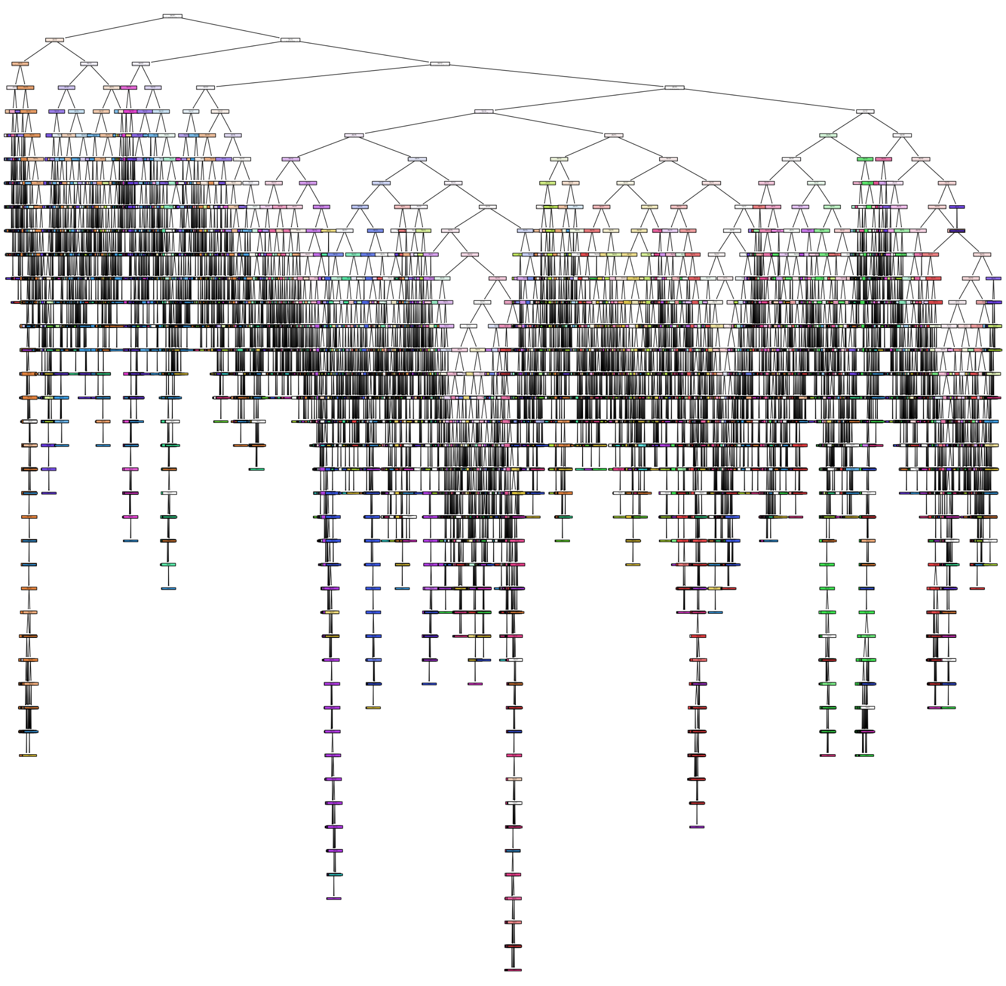

**Best parameters:**

With the default parameters of the algorithm, we obtain a decision tree with thousands of nodes and a considerable depth. Although the accuracy percentage is quite high, It is always a good practice to find a way to simplify the decision tree. A simple tree helps us avoid issues like overfitting, and it is easier to interpret and compute.

We can play the following parameters (if you don’t pass any parameter, it will run the algorithm with default values):

*class DecisionTreeClassifier(*

*\*,*

*criterion: Literal['gini', 'entropy', 'log_loss'] = "gini",*

*splitter: Literal['best', 'random'] = "best",*

*max_depth: Int | None = None,*

*min_samples_split: float | int = 2,*

*min_samples_leaf: float | int = 1,*

*min_weight_fraction_leaf: Float = 0,*

*max_features: float | int | Literal['auto', 'sqrt', 'log2'] | None = None,*

*random_state: Int | None = None,*

*max_leaf_nodes: Int | None = None,*

*min_impurity_decrease: Float = 0,*

*class_weight: Mapping | str | Sequence[Mapping] | None = None,*

*ccp_alpha: float = 0*

*)*

We have focus on the following parameters:

* **criterion**: The function to measure the quality of a split. It can be either “gini” for the

Gini impurity or “entropy” for the information gain.

* **max_depth:** The max_depth parameter specifies the maximum depth or levels allowed for the decision tree.
* **min_samples_split:** The minimum number of samples required to be at a leaf node.
* **min_impurity_decrease:** A node will be split if this split induces a decrease of the
* impurity greater than or equal to this value
* **max_leaf_nodes:** The max_leaf_nodes parameter limits the maximum number of leaf nodes in the decision tree. It allows for controlling the complexity and size of the tree.

Applying Grid Search with the following parameters:

* params: {

'criterion': ['entropy','gini'],

'min_impurity_decrease': [0.0, 0.01, 0.02, 0.05],

'min_samples_split': [2, 5, 10, 20],

'max_depth': [10, 20, 30, 50],

'max_leaf_nodes': [20, 40, 60, 80, 100]

}

The best accuracy value is using this values of parameters:

* 'criterion': entropy
* 'max_depth': 20,
* 'max_leaf_nodes': 100,
* 'min_impurity_decrease': 0.0,
* 'min_samples_split': 2

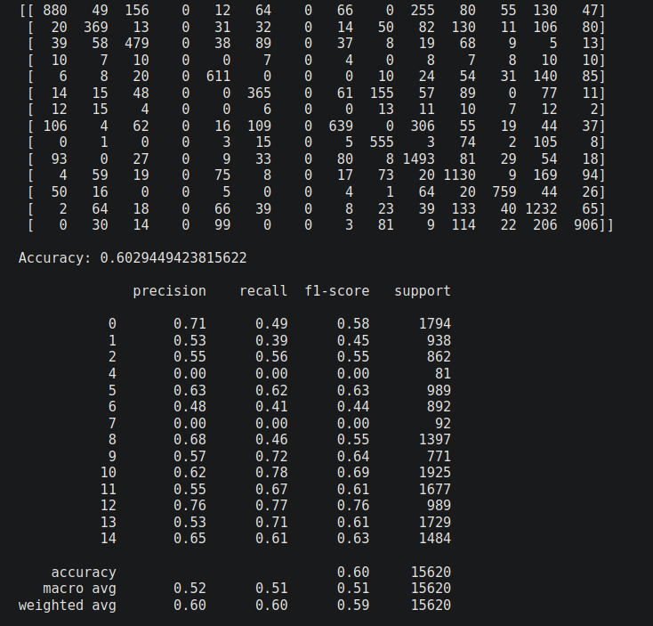

We can see that the accuracy has decreased compared to the default version, from 0.94 to 0.60. However, we believe it is worth it because in the previous version, we had a huge tree with approximately 8000 nodes, out of which 4000 were leaves. Now, it is reduced to 199 nodes, out of which 100 are leaves: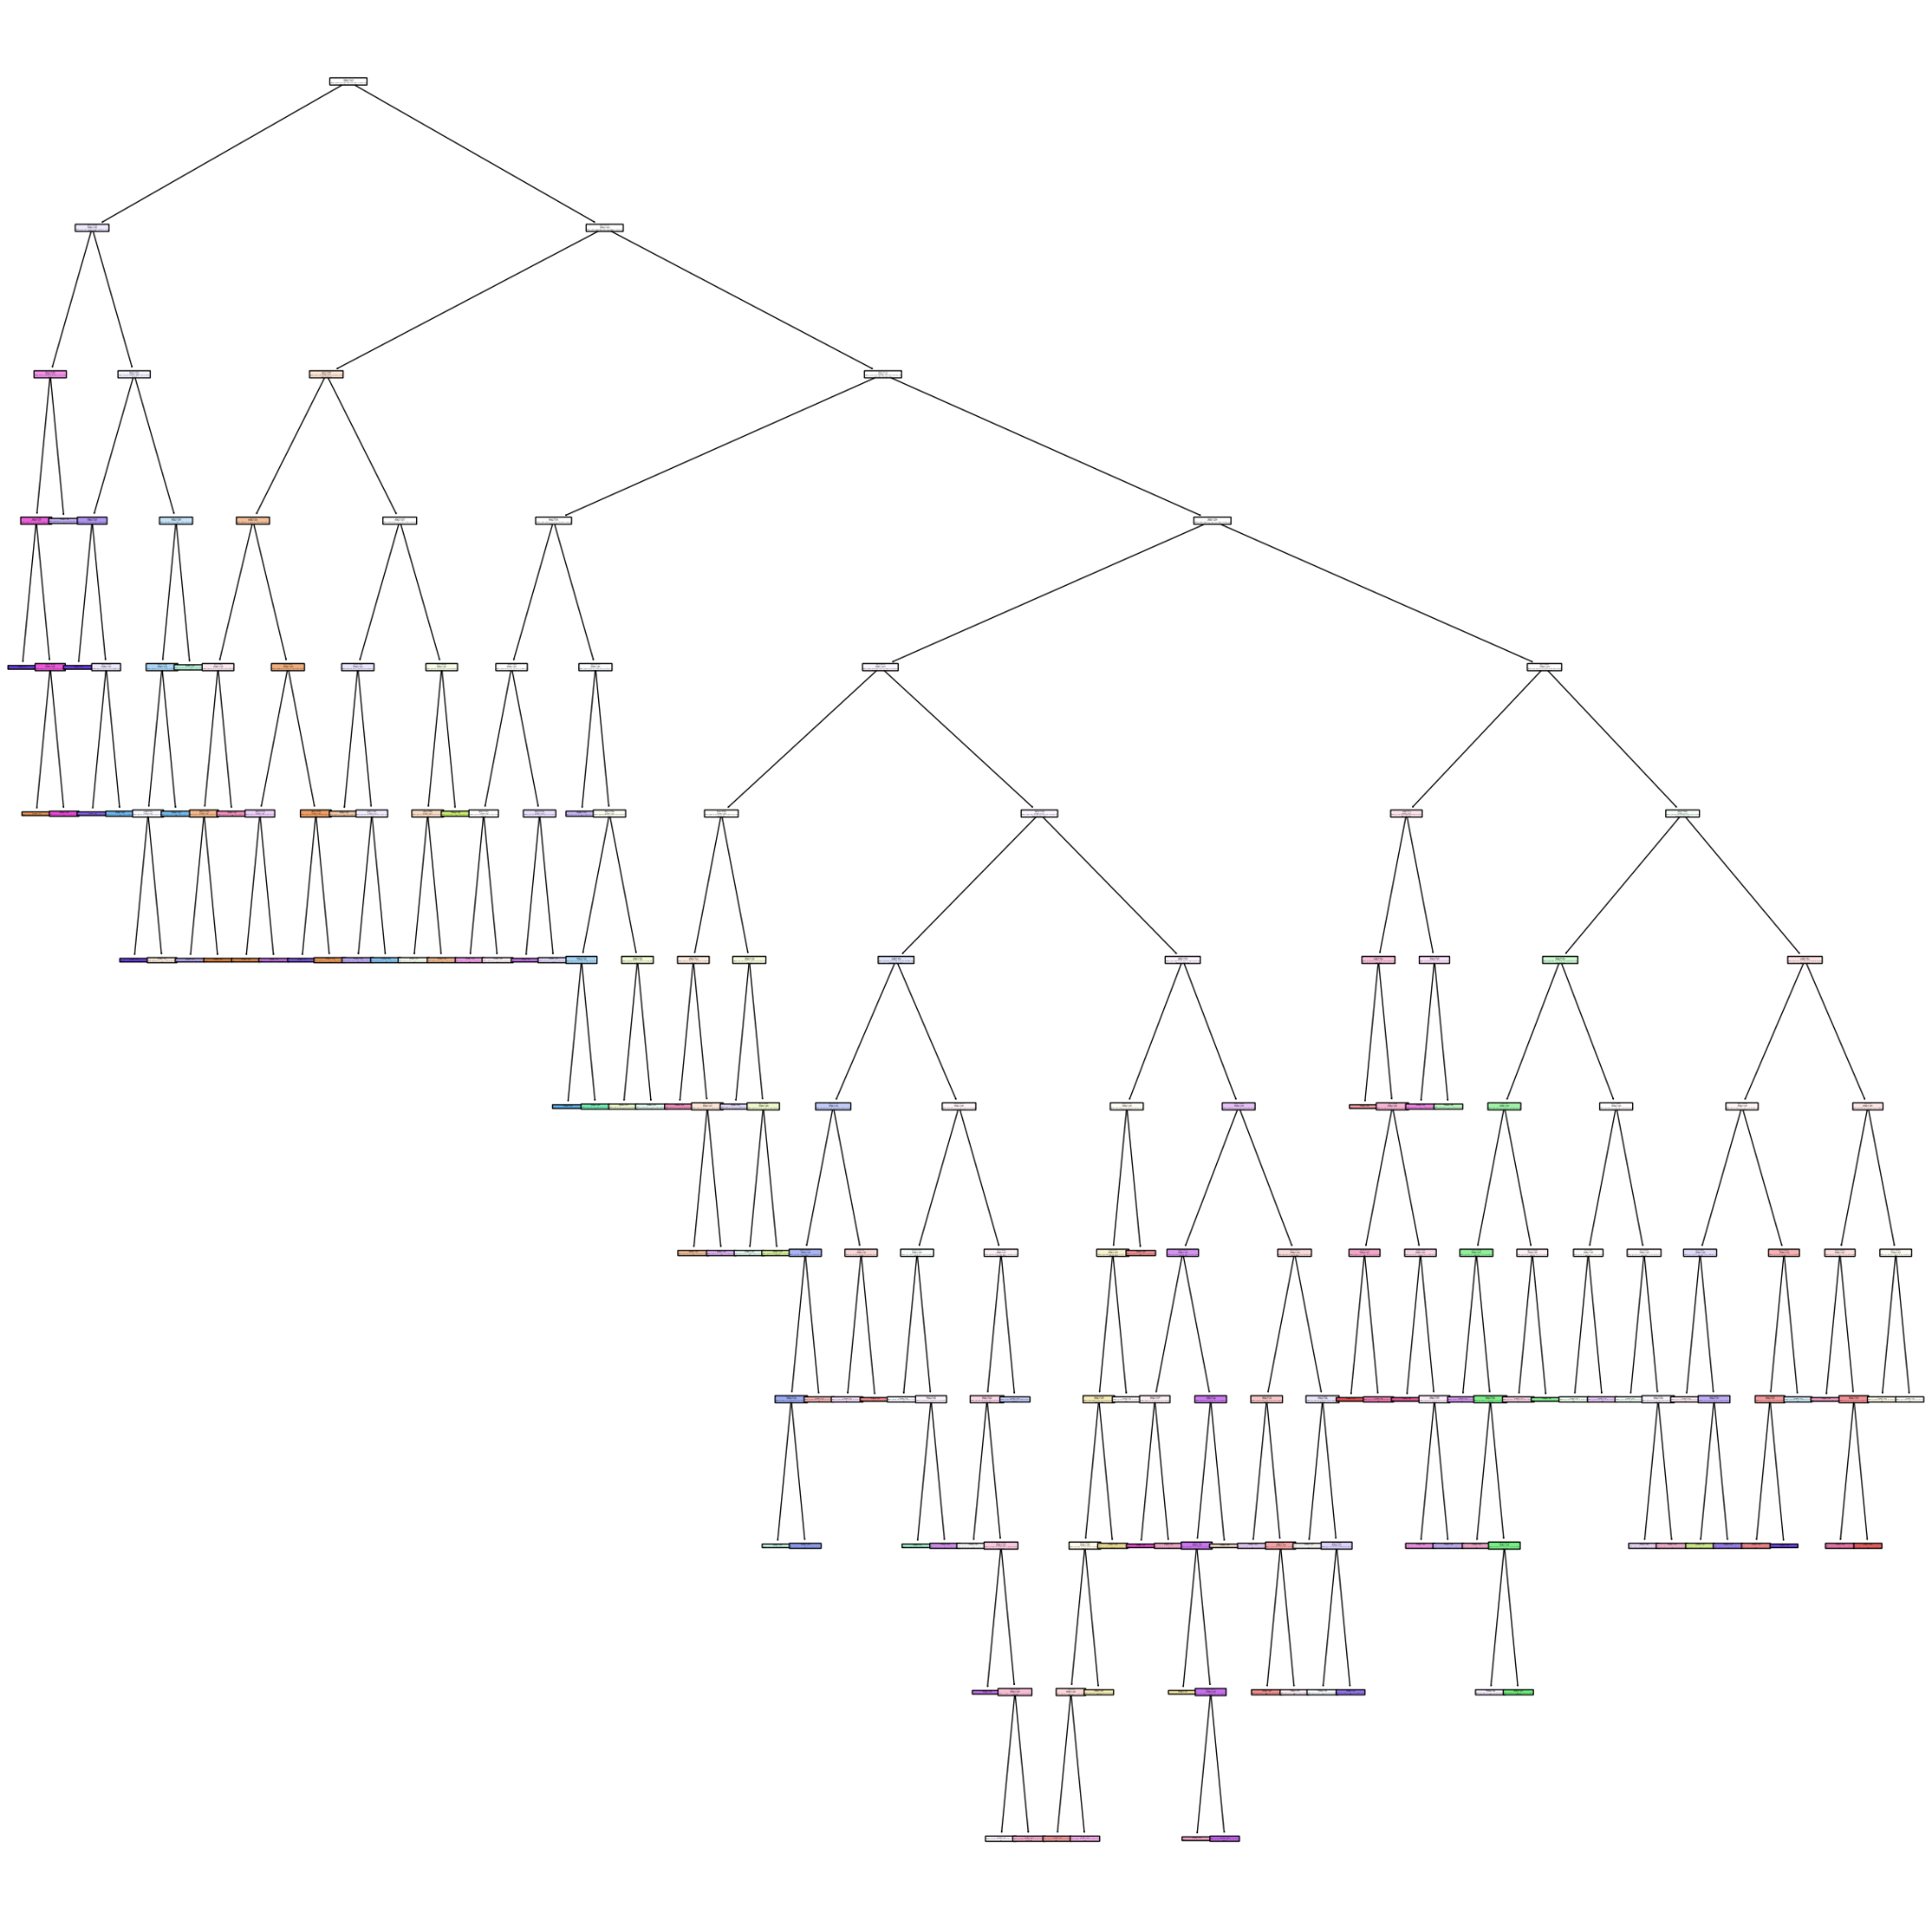

Now, based on the GridSearch we performed, we will focus on studying some parameters that we consider more important and try to improve the last version, as an accuracy of 0.60 seems quite low compared to the default version.

From the GridSearch results, we can see that 'min_impurity_decrease' and 'min_impurity_decrease' have taken the smallest values we provided. On the other hand, 'max_depth' and 'max_leaf_nodes' have increased, with 'max_leaf_nodes' even taking the highest value we provided. We have decided to focus the study on these last two parameters.

Effect of parameter 'max_leaf_nodes':

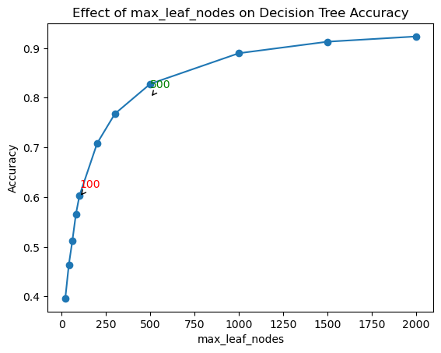

We have obtained a quite interesting graph that follows the law of diminishing returns: increasing the quantity of a productive factor in the production of a good or service leads to a decrease in the productivity as we increase this factor.

If we increase the quantity of a productive factor while keeping the quantity of the remaining factors fixed, there will come a point where the quantity of the final product obtained decreases as we continue to produce more and more. An example of this is the relationship between production and workers.

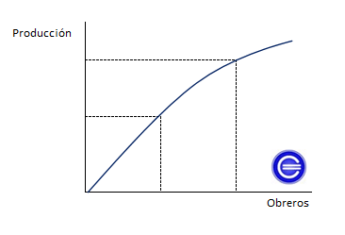

Therefore, as capitalists, we are interested in having the fewest number of workers (leaf nodes) to maintain high production (accuracy). In other words, we aim to maintain productivity. We can observe that for an accuracy of 0.6, it is necessary to have a minimum of 100 max_leaf_nodes, which aligns with the previous result. However, to achieve an accuracy of 0.8, we need around 500 max_leaf_nodes. There is a clear decrease in productivity in this case.

Effect of parameter 'max_depth':

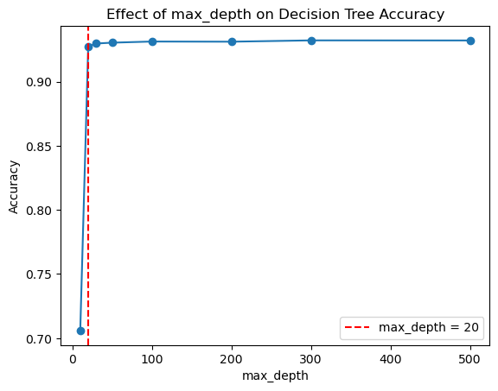

Regarding max_depth, we can see that when it has a value of 20, it can reach an accuracy of over 0.90. It's important to remember that in this case and the previous one, we didn't impose any restrictions on max_leaf_nodes. Therefore, here we are representing the highest accuracy we can achieve without limiting the number of nodes, specifically for max_depth=20.

Next, we will study the behavior of accuracy in relation to max_depth and max_leaf_nodes using a heatmap.

Effect of parameter 'max_leaf_nodes' and 'max_depth':

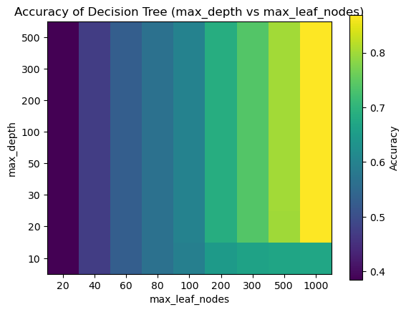

In this heatmap, we can see that the parameter that truly affects the accuracy is 'max_leaf_nodes'. Without changing the value of this parameter, just altering the max_depth barely results in any accuracy variation, which makes sense since without nodes, we cannot expand the tree. The highest value of max_depth with effects on accuracy is 20. Knowing this, we can now generate the decision tree with the desired accuracy, taking into account the graph of the effect of the 'max_leaf_nodes' parameter.

For example if we want a desicion tree with 0.7 of accuracy:

* max_leaf_node = 200
* max_depth = 20

